|  |
| --- |
|  |
| Database Write up |
| Andrew Burton 11DP |
|  |
|  |
|  |

**Database Task**

Mr Smith the owner of Smith & Son’s Hardware Store would like me to setup a database to keep track his customer’s orders. The Hardware shop sells a variety of tools. The database enables us to efficiently store customer’s details

He wants a database to provide the following services (Success criteria):

1. Easy method of adding new customers and purchase information
2. Being to print a monthly sales report
3. Print a monthly report showing customers who have spent over £50 each month
4. Have an efficient method to search for customers
   1. Who have spent over £50 each month – mail merge list for Xmas card/voucher
   2. Who have bought 10 products – inform them of new product
   3. Orders over 10 – offer discount
5. Have an efficient method to search for supplier details and request new stock
6. Efficient method to update an existing customer information

The advantage of having a database is that the customers could receive a faster service when they enquired about their order, since the data can be obtained within seconds since no paperwork is involved. It also easily allows them to quickly create new records without needing to deal with paperwork, and allows them to easily backup the data, since it can be copied to a removable memory device.

The fields used in the database are shown in the table below. Before I inserted the details below into Access I first filled out the database planning sheet which can be seen in appendix A. I have listed the fields I need below.

|  |  |
| --- | --- |
| **Customer details** | **Order details** |
| Customer id | Order id |
| Customer title | Description of item |
| Customer firstname | Price |
| Customer lastname | Qty |
| House name / no | Date of order |
| Address (road) | Supplier name |
| Address (town |  |
| Address (county) |  |
| Address (postcode) |  |
| Phone no |  |
| Customer e – mail address |  |

I then specified the field length for each field. The values are shown in the table below.

|  |  |
| --- | --- |
| **Field** | **Field size** |
| Customer id | AutoNumber - size n/a |
| Customer title | 6 |
| Customer firstname | 25 |
| Customer lastname | 25 |
| House name / no | 30 |
| Address (road) | 30 |
| Address (town | 30 |
| Address (county) | 30 |
| Address (postcode) | 8 |
| Phone no | 11 |
| Customer e – mail address | 30 |

This is a screen print of the table I created.

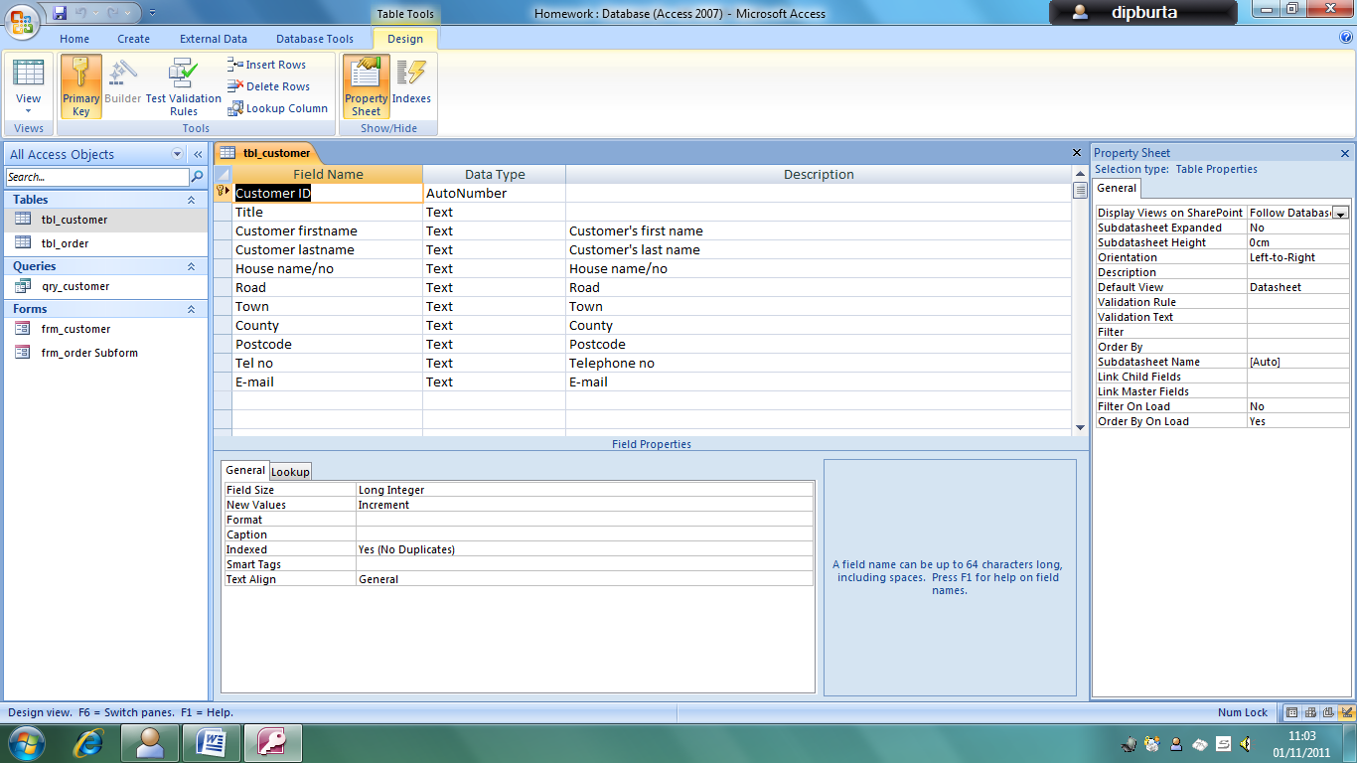

I then created a second table for the customer’s order details and added the following fields and specified the length for each text field

|  |  |  |
| --- | --- | --- |
| **Field** | **Field size** | **Format** |
| Order no | AutoNumber |  |
| Item description | 30 |  |
| Price per item | Currency | Eg. £10.00 |
| Quantity | Number |  |
| Date of order | Date/Time | Short Date |
| Supplier name | 25 |  |
| Customer ID | Number |  |

**Validation**

I then set up validation for some of the fields. This would help prevent incorrect data from being entered, and make it easier for the user. Details of the validation used can be seen in appendix A, and an example of the validation in use can be seen below.

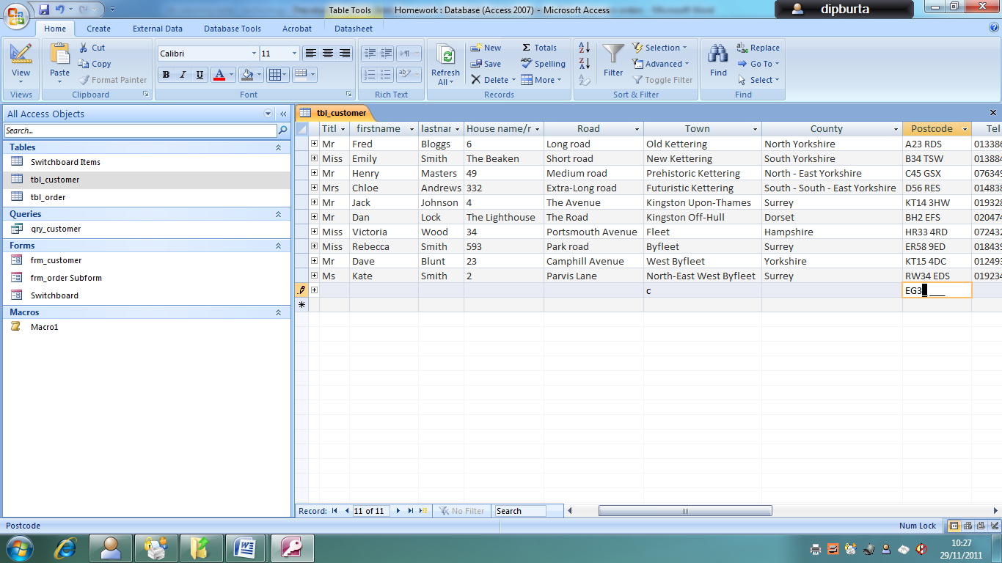

In the screen print above, the user is forced to enter a postcode as Letter Letter Number Number space Number Letter letter (e.g. EG32 9DF). If a user attempts to put a letter in a number space, then the character will not appear at all on the screen.

Another example of the validation can be seen below

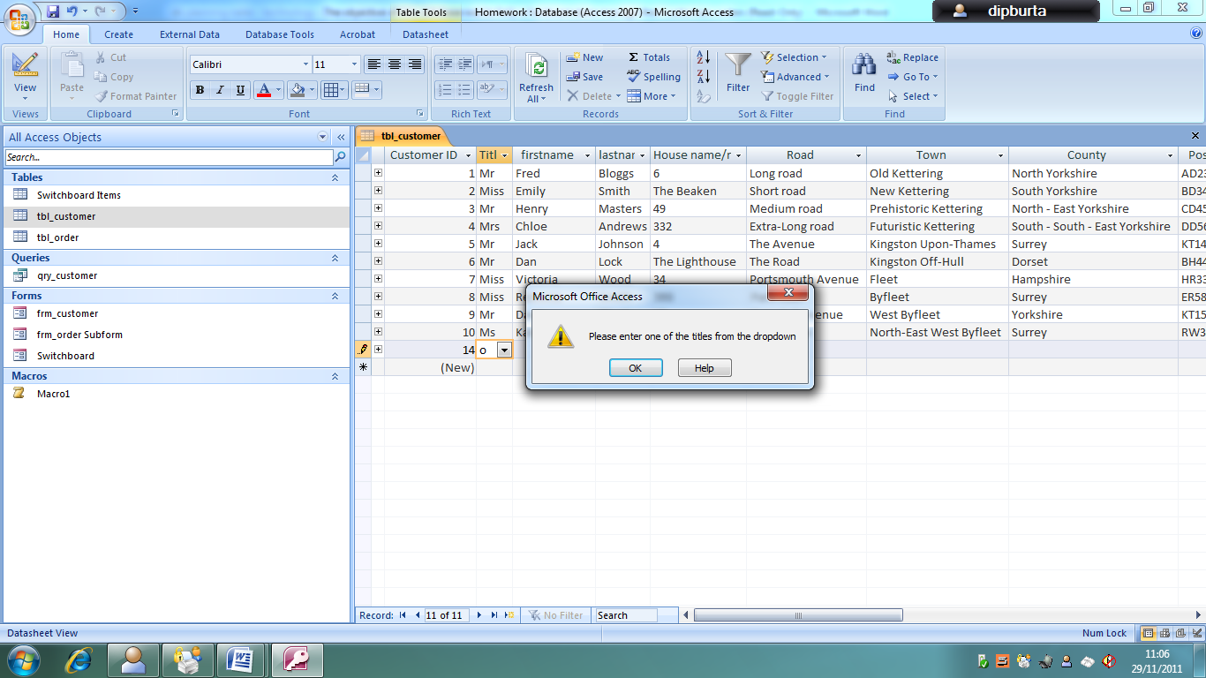

In the screenshot above, we can see the validation for the title field. If something is entered into the box which is not on the dropdown list (Mr, Mrs, Miss, Ms) then the dialogue box appears prompting the user to correct the error.

This can be seen in design view below

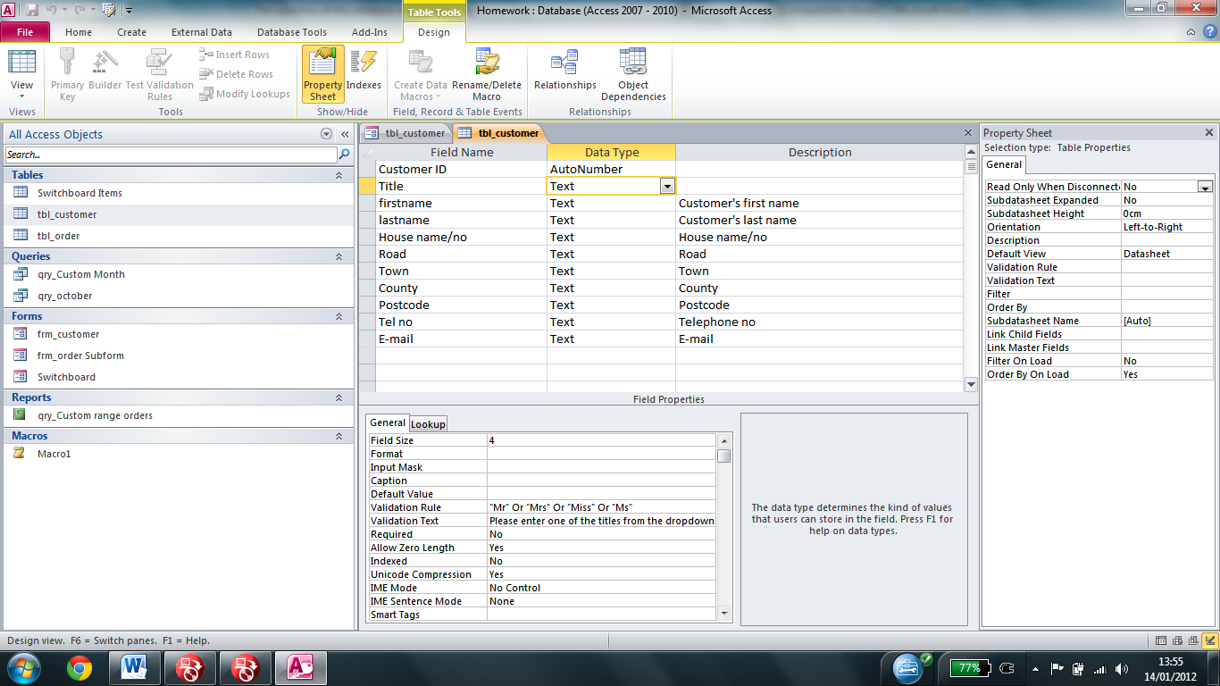

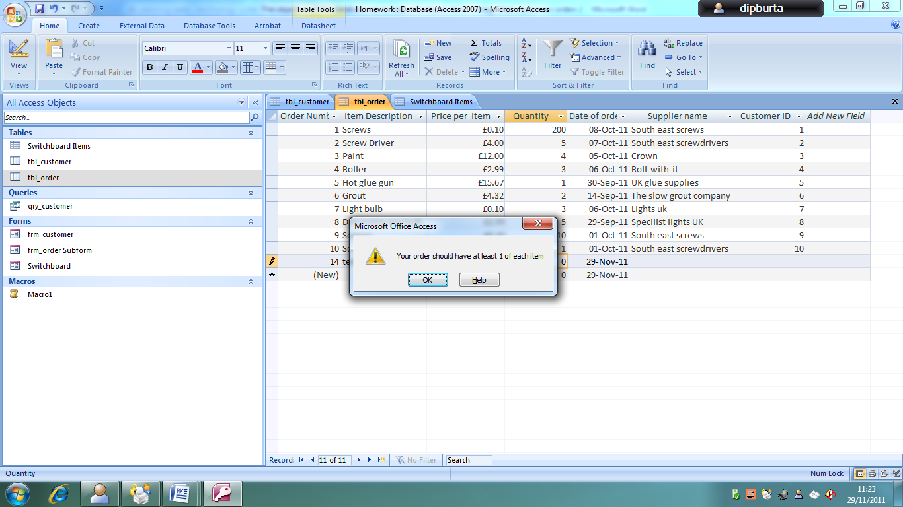Another example of the validation can be seen below

In the screenshot above we can see the validation for the quantity field. If a quantity is not entered, and is instead left at the default 0 values, then the dialogue appears prompting the user to correct the error (swap order)

**Relationship**

I then created relationships for the two databases as seen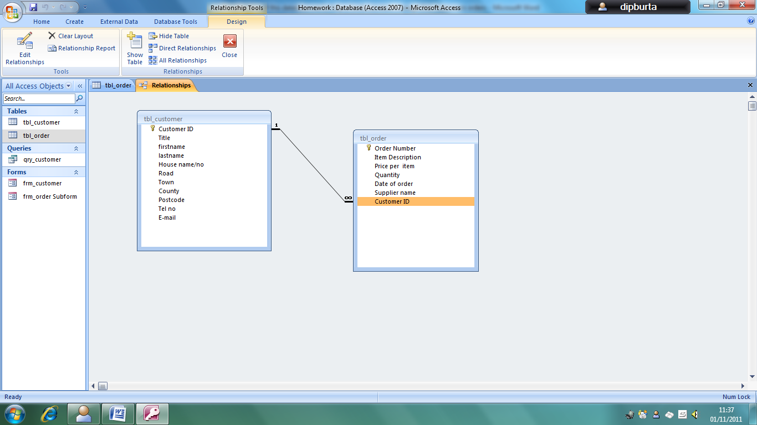 above.

The reason for using the relationships is to make the database more efficient since the database is clearer to understand in table view and to reduce the chance of duplicate information being entered into the database.

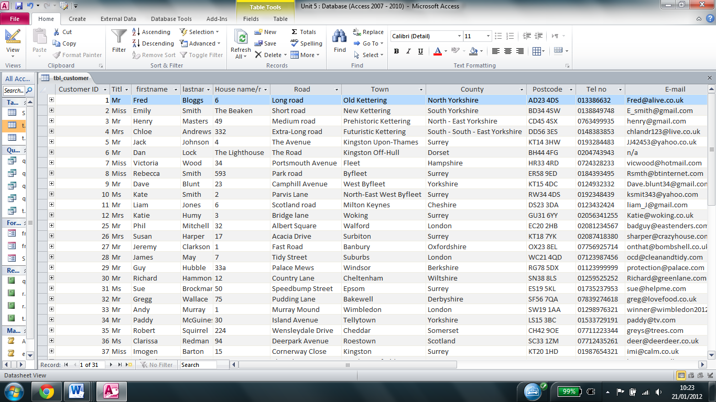I then inserted the data about the customers and their orders. A section of this data can be seen below.

The relationship means that the customer details table also features the order details, making it easier to understand as shown below.

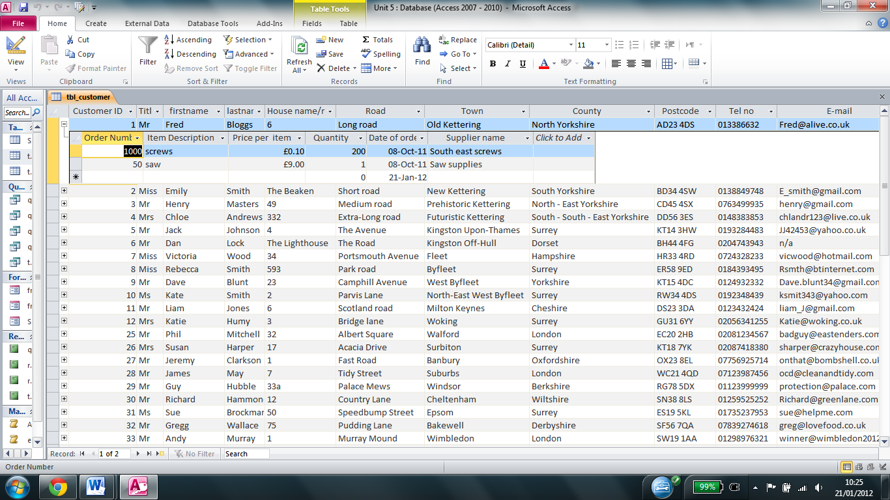

**Data entry form**

I then created a form to allow users of the database to view and edit existing orders and customer’s details, and is easier to use than using the table. I also added buttons to allow users to easily switch between records, create and save new records, and jump to the first and last record.

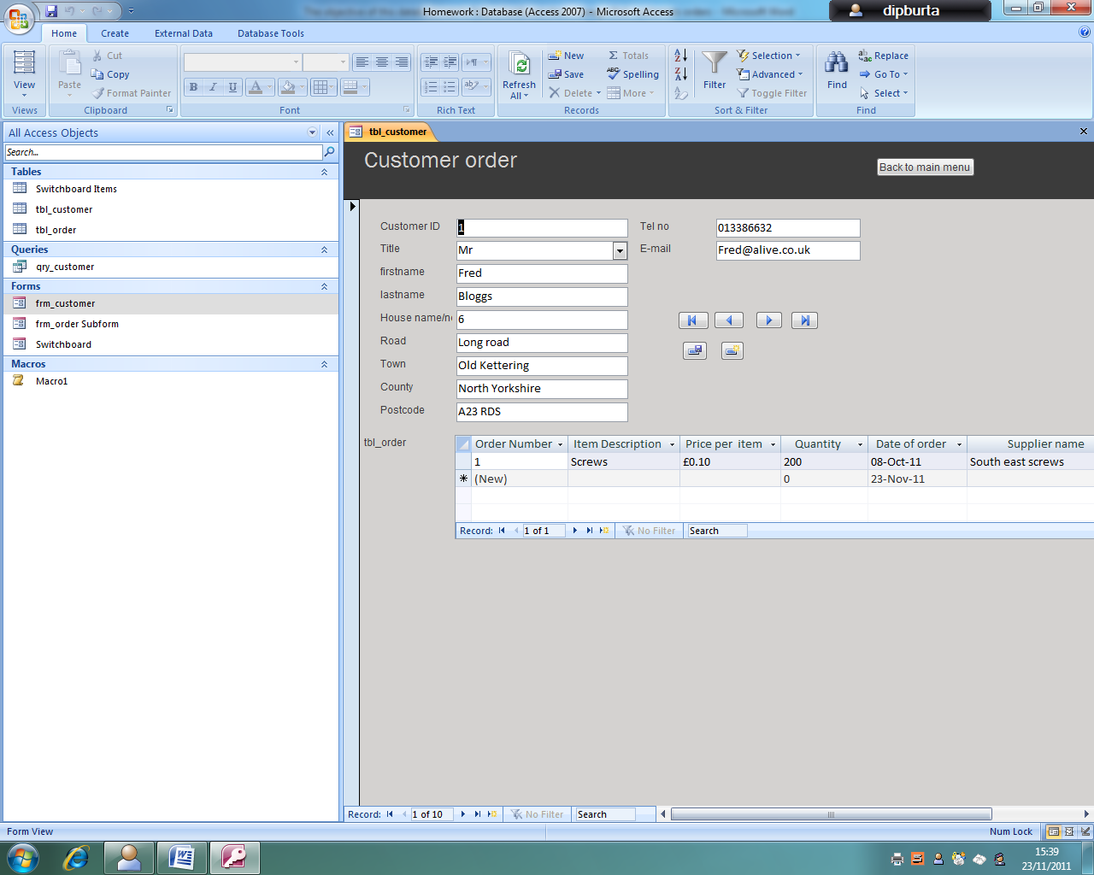An example of the form can be seen below.

The back to main menu button provides an easy way to return to access

The navigation buttons allow users to easily jump between records and create and save changes

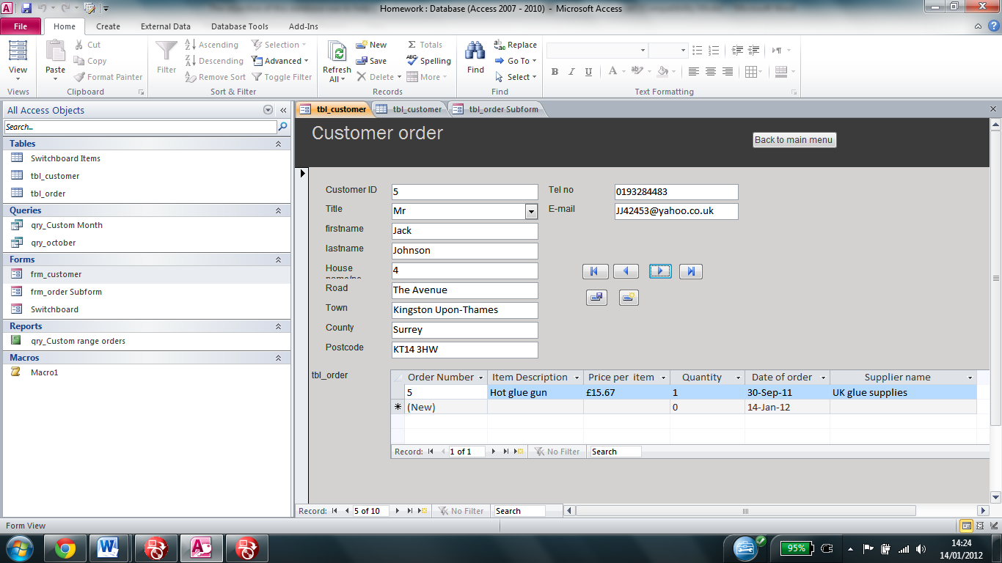

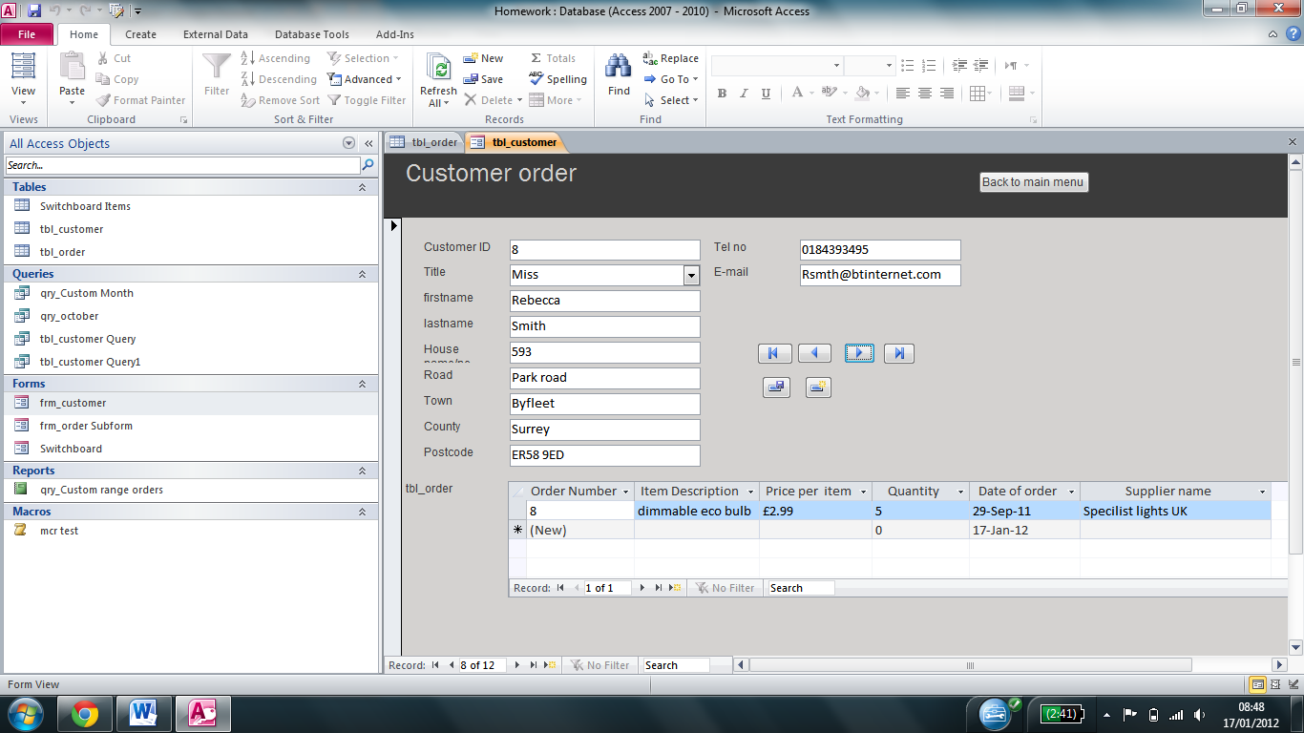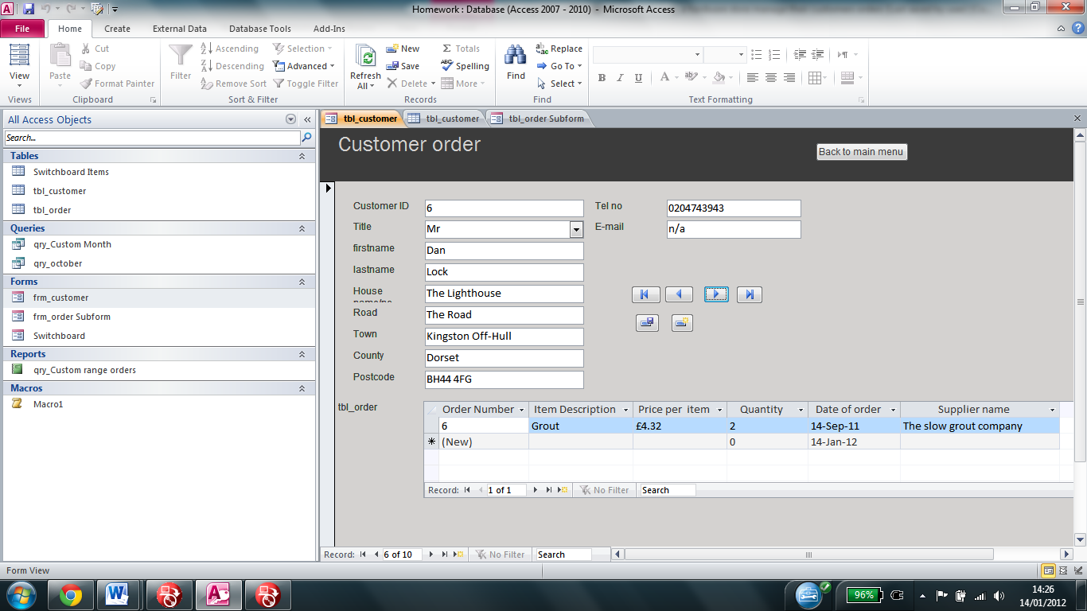

**Switchboard**

I then created a switchboard to make it easier for the user to manage the database, since all of the main options can be easily accessed. The switchboard acts as a menu for the database, allowing the user access to all of the most important functions of the database easily and quickly. I also added a “Back to main menu” to the form to make it easier for the user to return to the switchboard when they have finished editing the customer details. The switchboard as it was when I created it can be seen below

Exit button in corner (not shown)

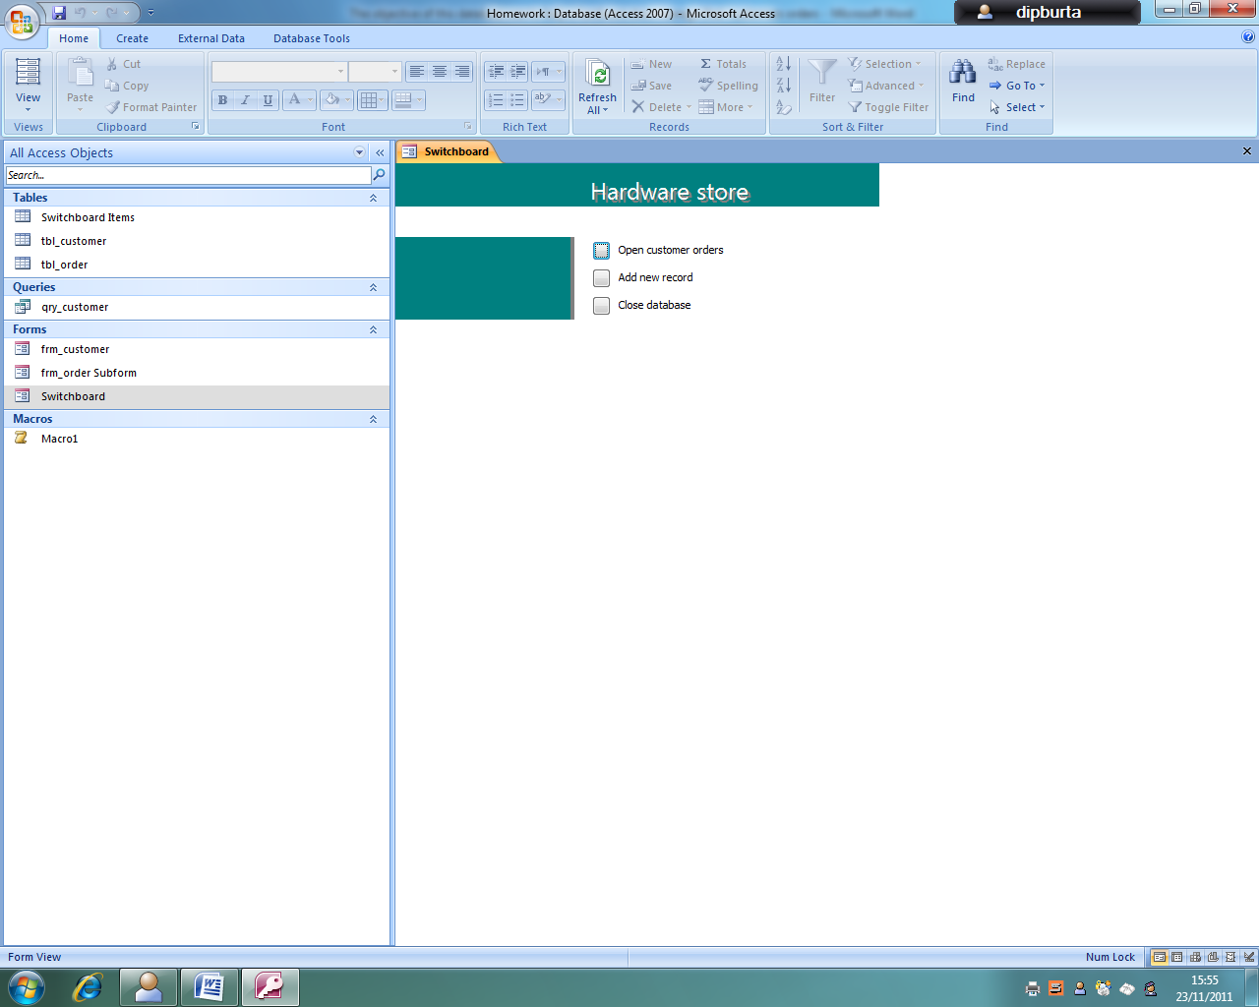

Closes Access

Opens table

**Creating a report showing “all orders over £50”**

In order to create a report I had to initially create a query. A query allows the user to search for all records with the same criteria. I created criteria with a custom date option which could be used to work out how many orders the store has received over a period of time. When the user clicks on it they are prompted to enter the date range for which they are searching for. It would also show all orders over £50.

To get it to show all orders over £50, I first created a new field and opened the expression builder to create the expression shown below

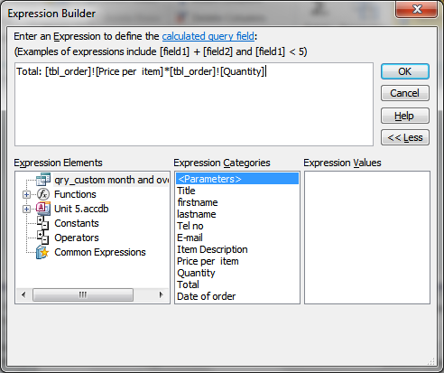

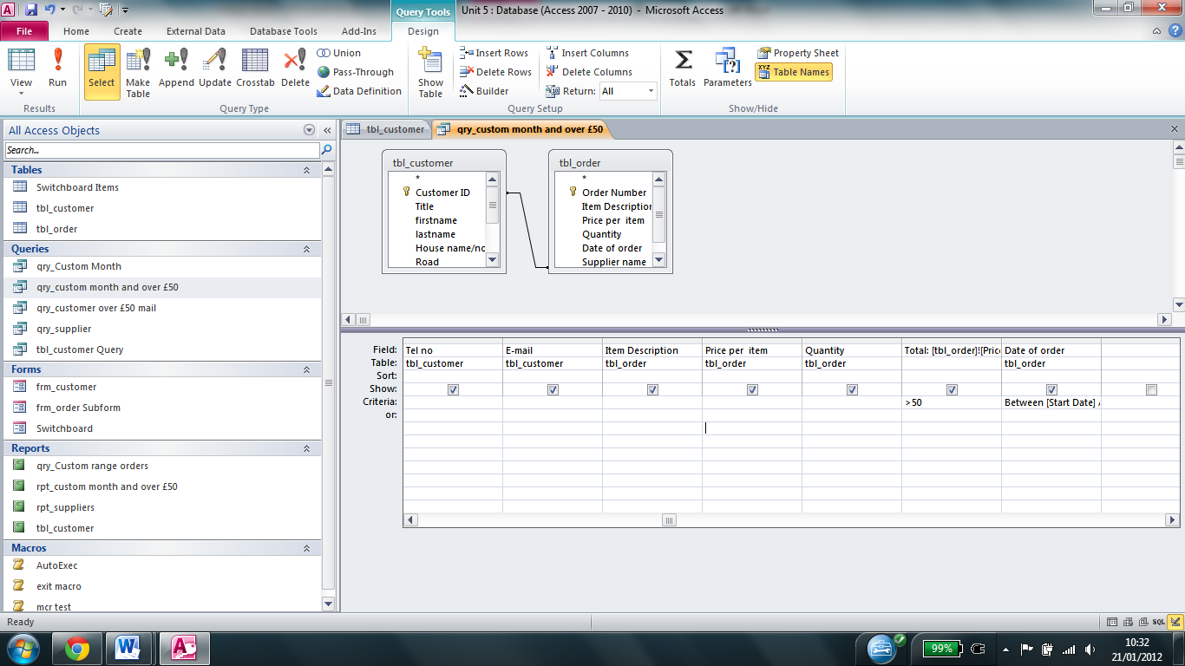The query can been seen in design view below

An example of the query being run can be seen below

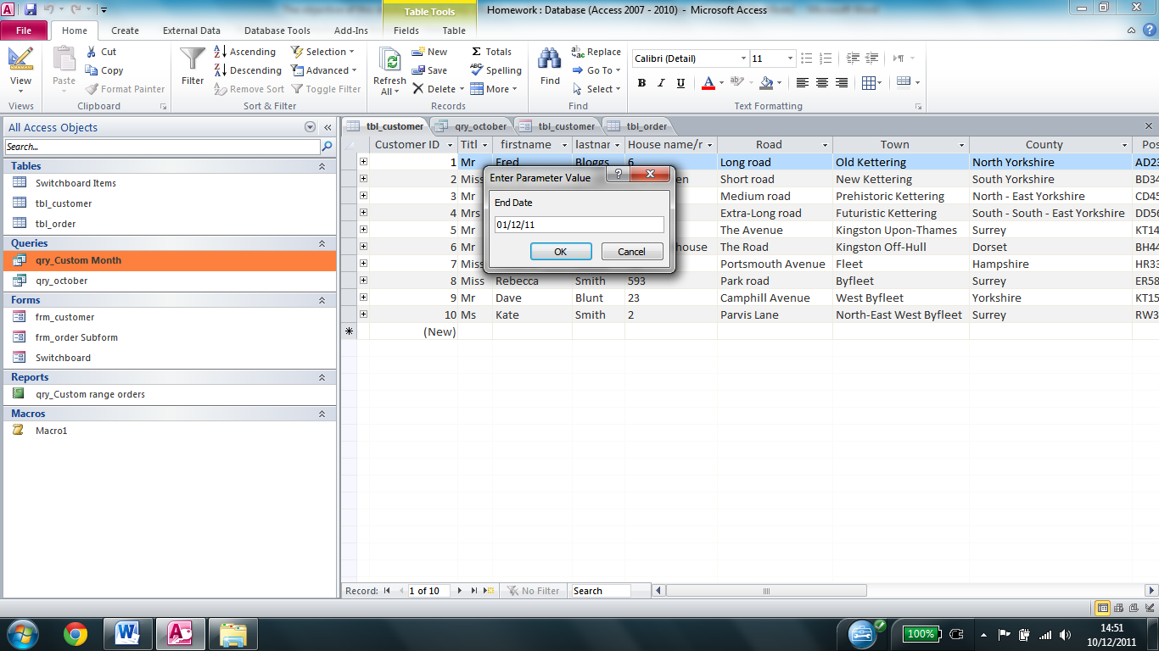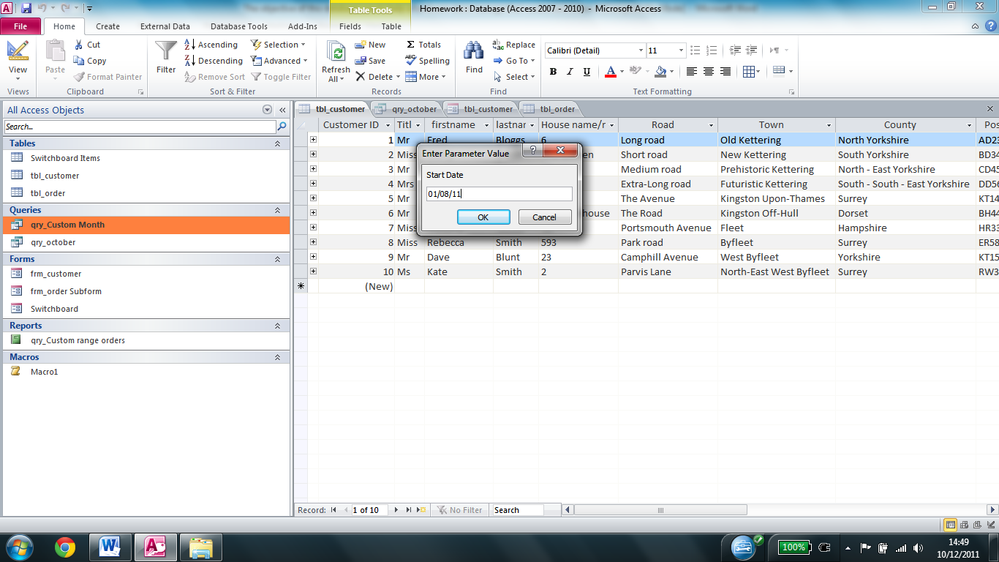On entering the two dates results for the query show up like this

Here we can see the database prompting the user for the end date they wish the report to show

Here we can see the database prompting the user for the start date they wish the report to show

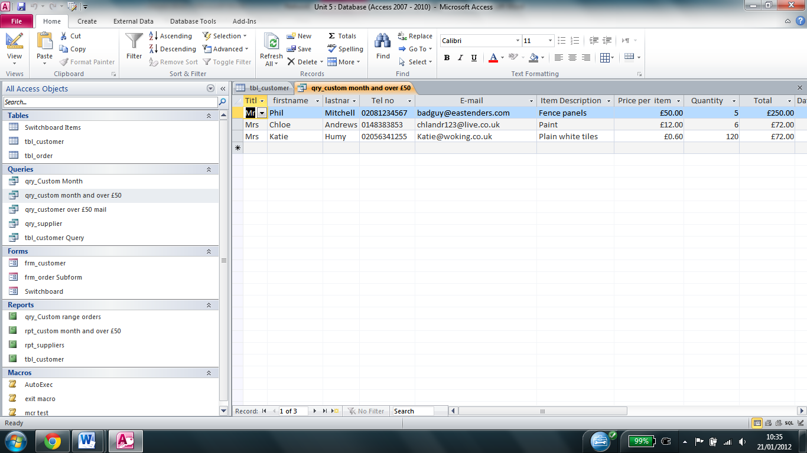

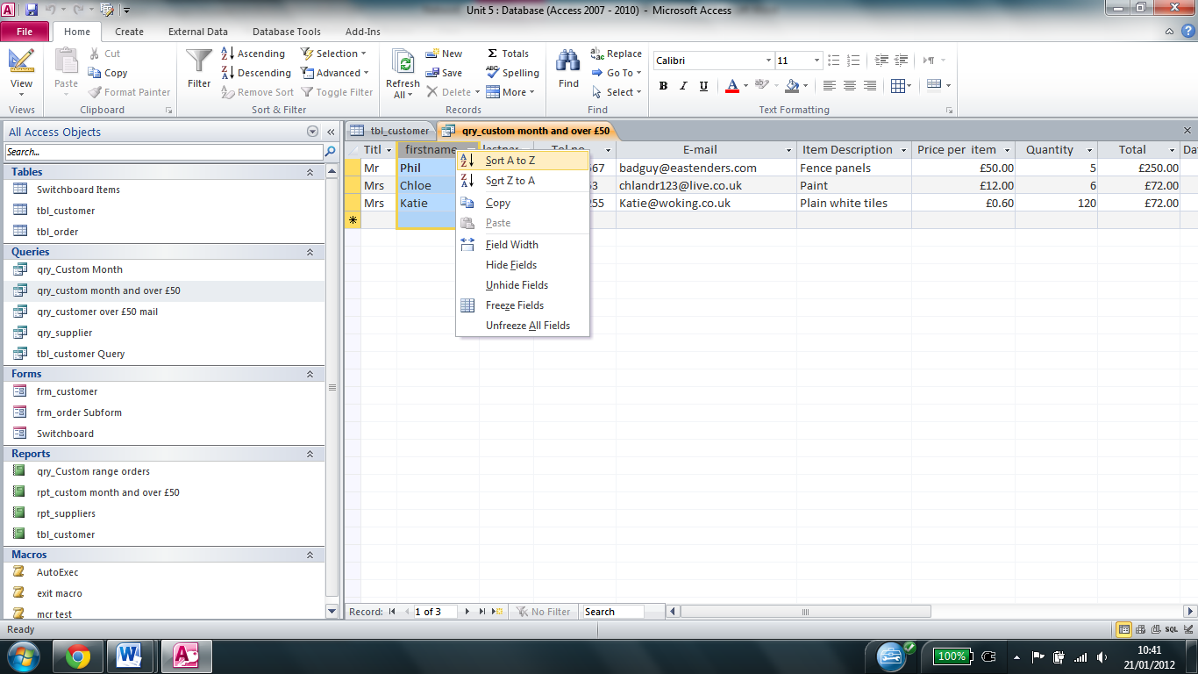As shown above, the fields are sorted by first name, however a user can easily change it by right hand clicking on the field name that they want to sort by, and choosing to either sort it by A – Z or Z –A

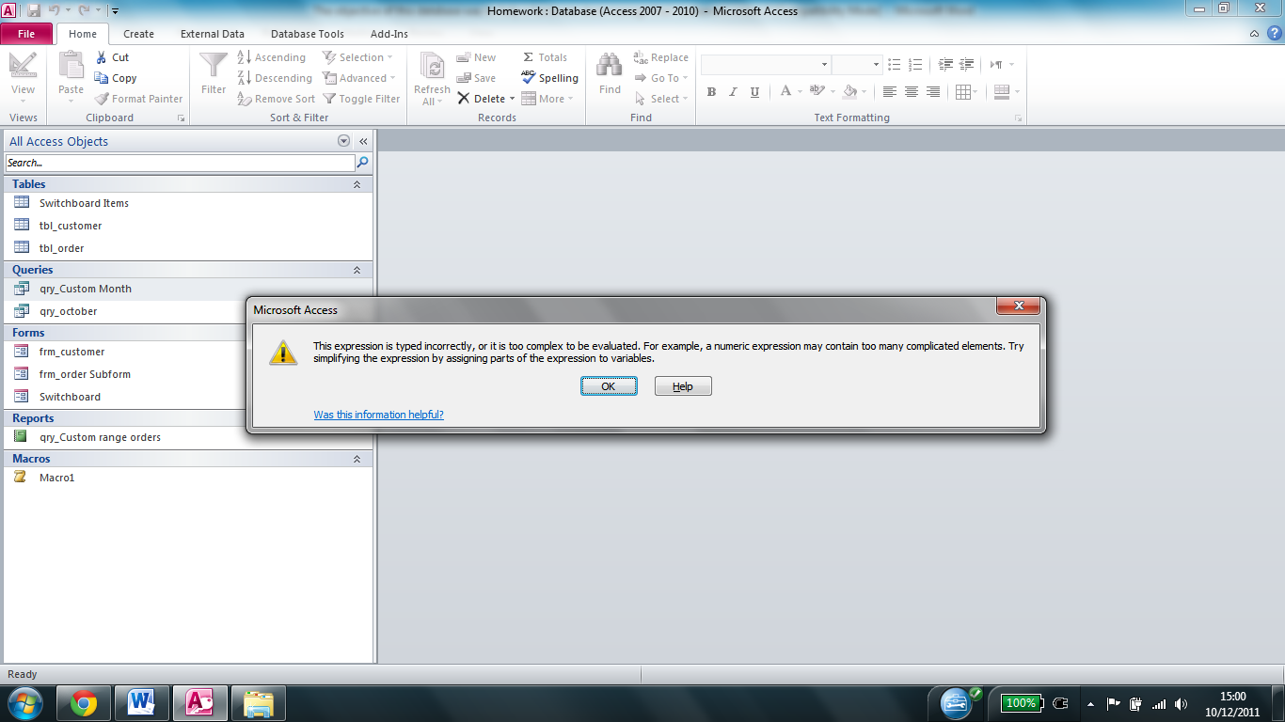If incorrect data is entered (e.g. numbers, text) then the following message appears prompting the user to correct the incorrect data.

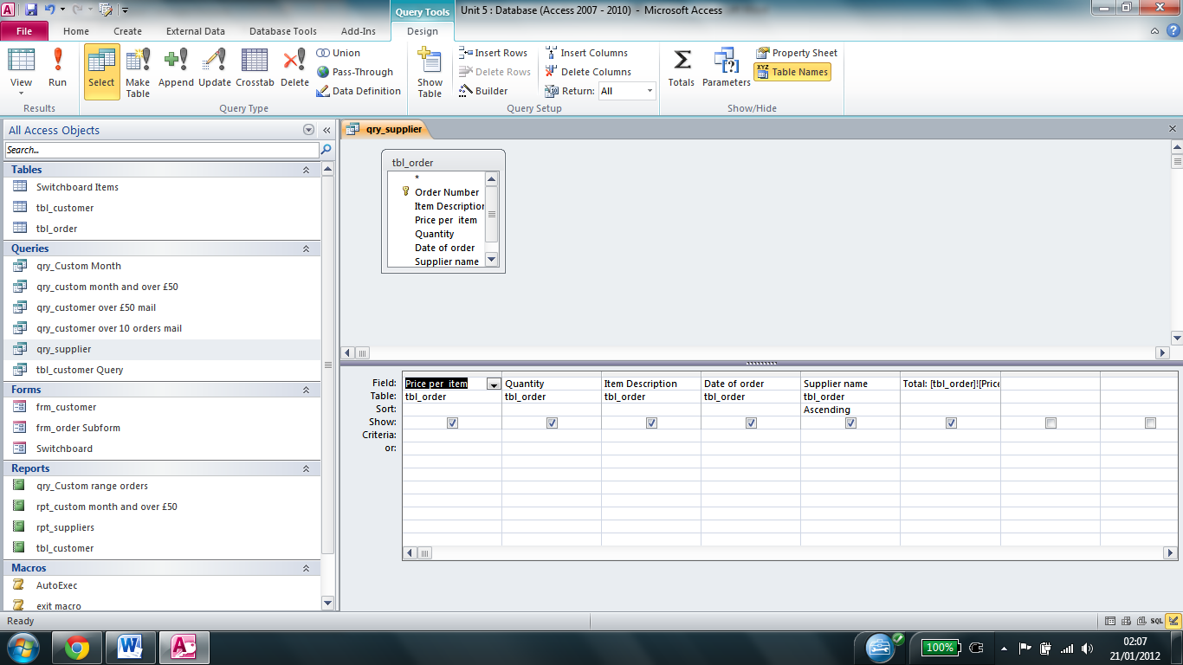I also created a query which allowed the user to view all orders sorted by supplier (as shown under sort under supplier name). It can be seen in design view below.

When the query is run, it produces something like this

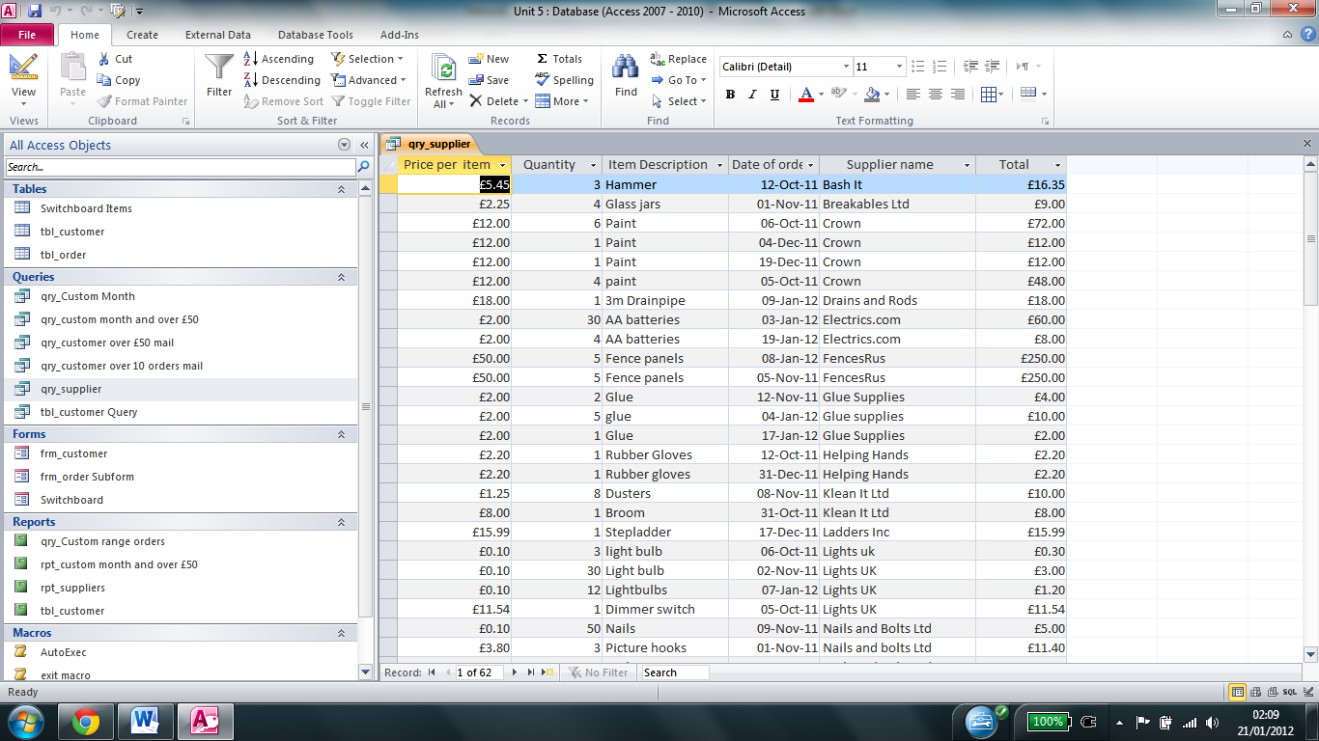

**Report**

I also created a report for the query which prompts users in the same way as the query, but is easier to understand than the query view and has adjustable field lengths making it easier to understand when printed, which will make it easier to track customers ordering habits on a month by month basis.

A screenshot of the report with the same criteria as the query detailed above can be seen below

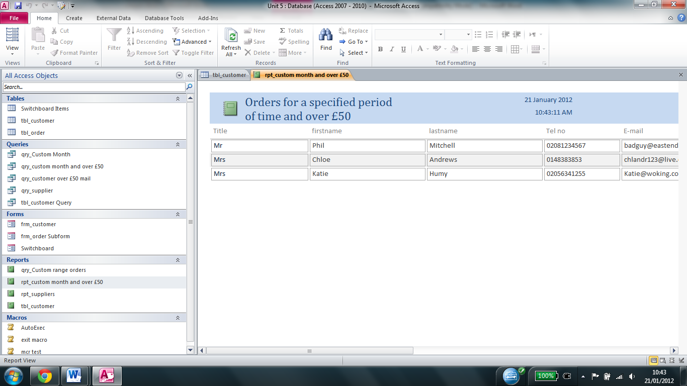**<SHRINK FIELDS so all data in visible>**

I then added a shortcut to the report to the switchboard. When clicked, it will prompt for the date range in the same way the query does, but then it will show the report.

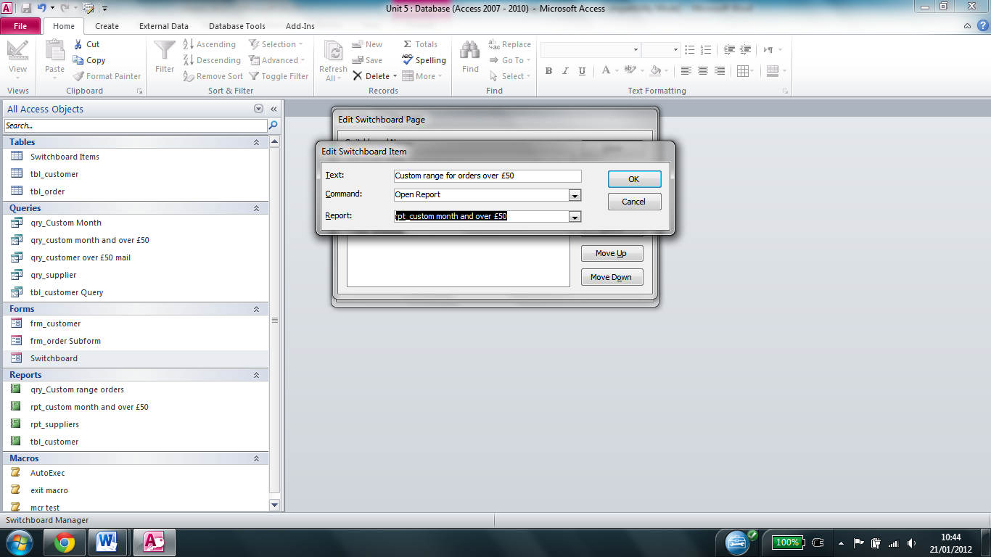

I also created a report for the supplier query to make it easier for the user to understand when it is printed

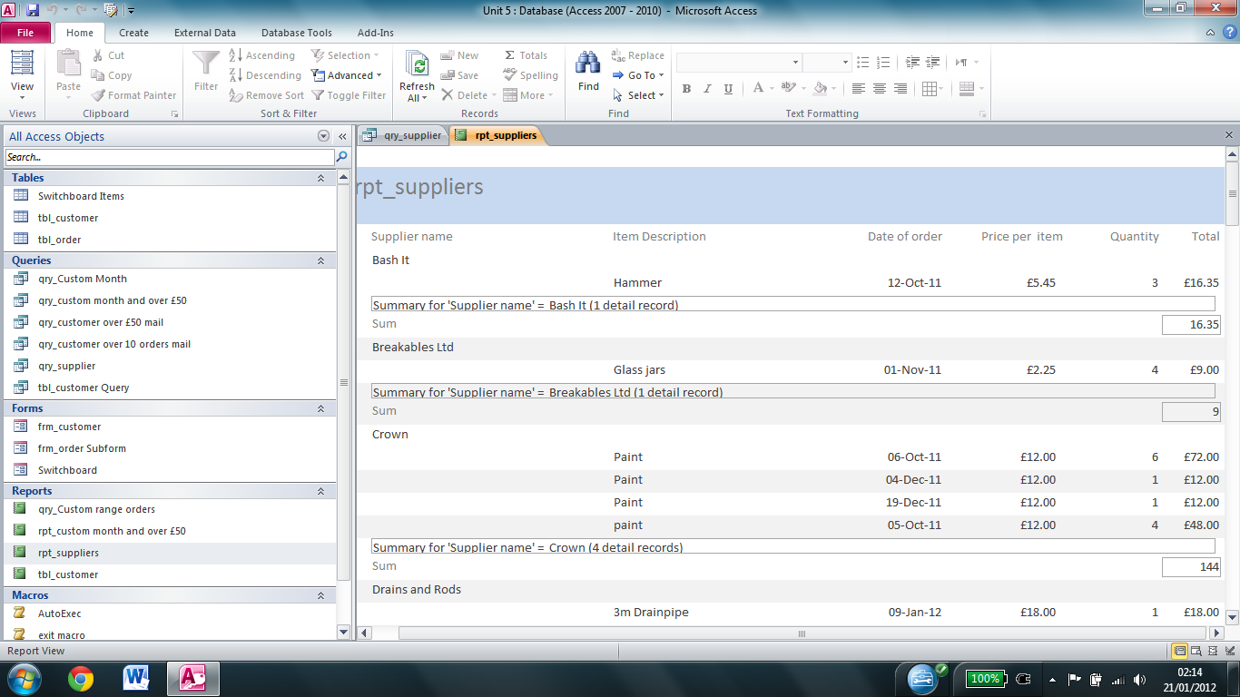

**<Change report title – to more appropriate & format Sum to currency ex. £144.00>**

I then added a shortcut to the report to the switchboard

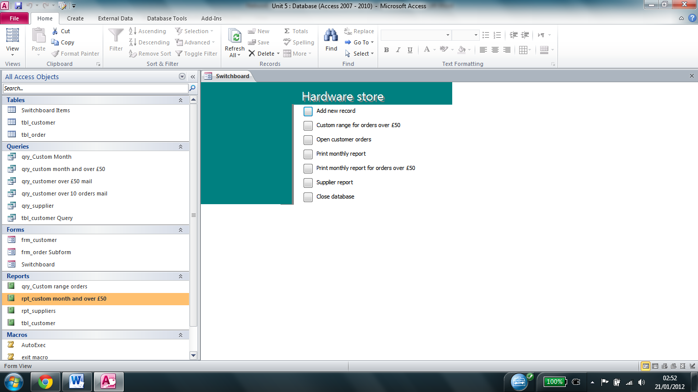

**Macro**

I then created a macro which could be used to generate and print a report on a monthly basis. This will save time and confusion, since the macro is easy to use. It is shown in design view below

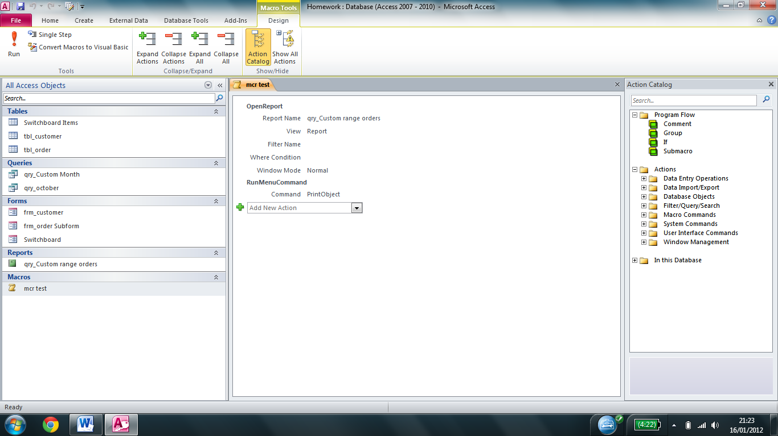

When the user clicks on the macro, they are prompted to enter the month they wish to print as with the query. Once this data has been entered, then the following screen will appear prompting the user to select which printer and any additional options (e.g. number of copies)

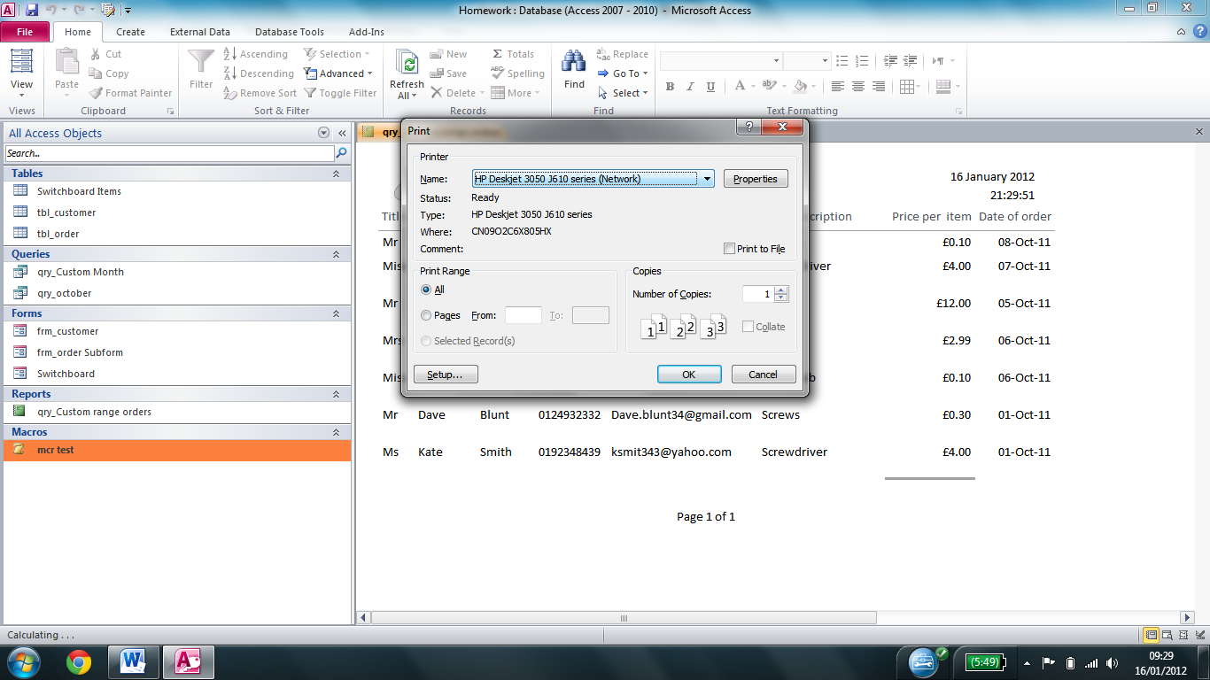

In this case the HP printer has been selected and 1 copy has been specified. The user also has the option of specifying the number of pages if there are multiple pages in the report generated.

I then added a shortcut to access the macro to the switchboard, and labelled it print monthly report.

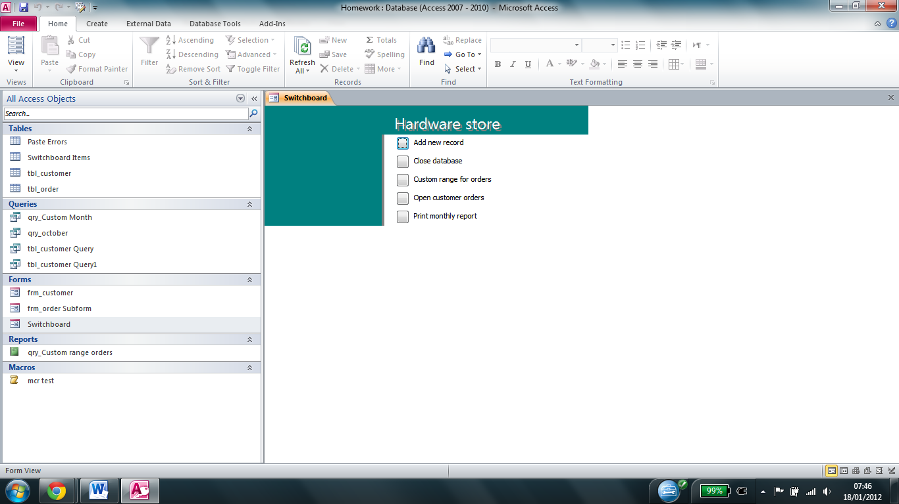

I also created a m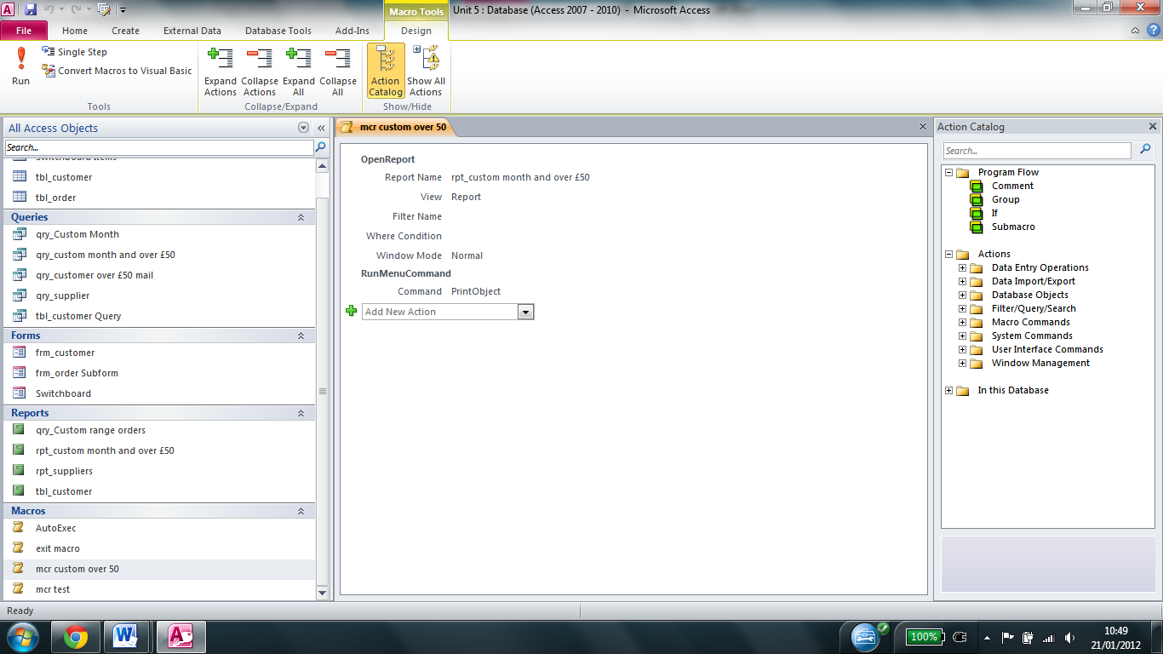acro to print a monthly report for orders over £50. This can be seen in design view

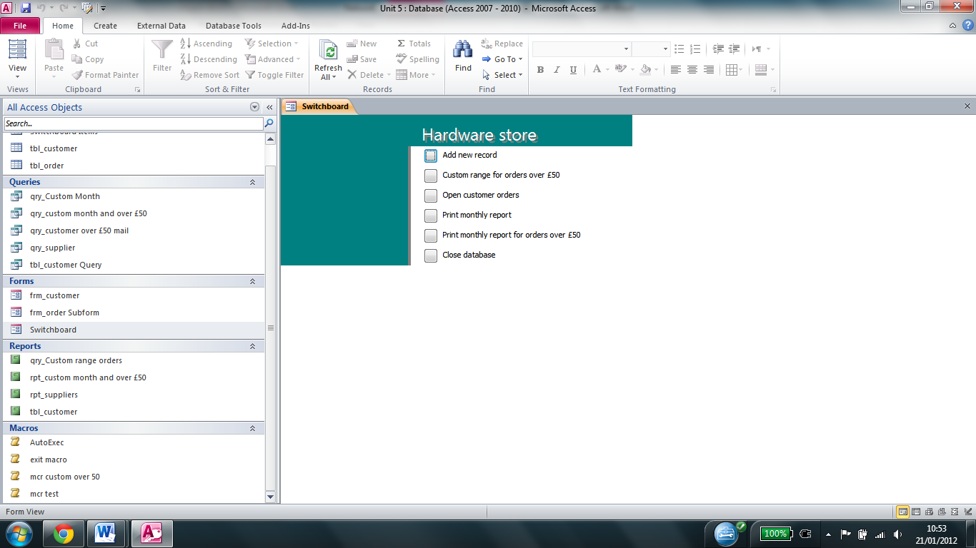I then added a shortcut to the other macro to the switchboard

I also created a macro to automatically open the switchboard. It can be seen in design view below

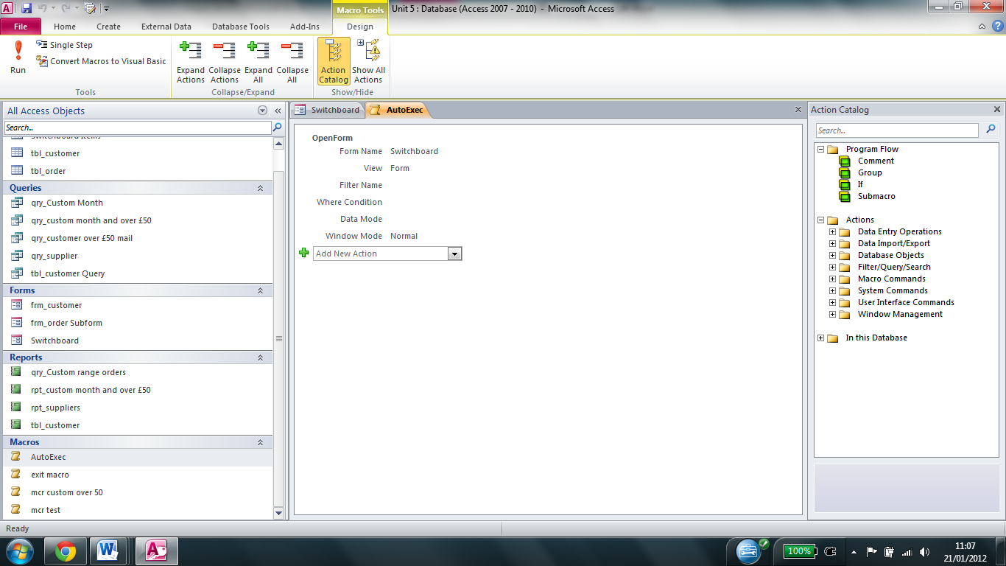

I named the macro AutoExec. The reason for this is because if there is a macro named AutoExec, access will automatically run it.

I also created a macro to close access when it is run, saving any open windows in the process. I added it to the switchboard, and it can be seen in design view below

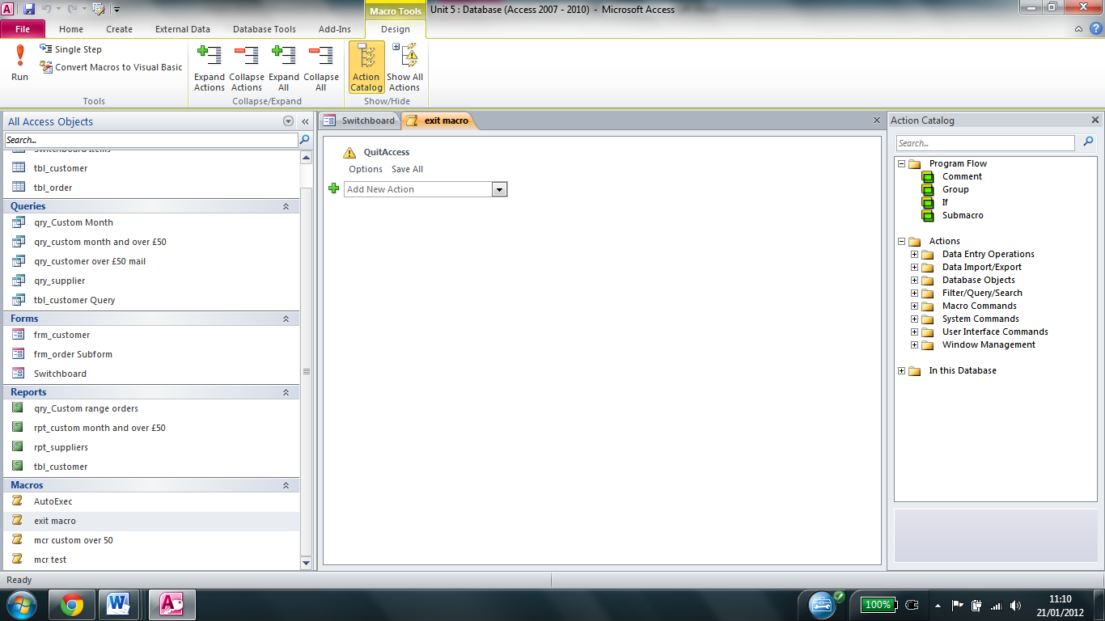

I also created a macro for the save button which when run would tell the user that the records have been saved. This is useful since then the user knows that the data has been saved, and it saves them having to close it.

I first right hand clicked on the save button and clicked properties. I then chose the event tab, and clicked on the 3 dots next to [embedded macro] next to on click

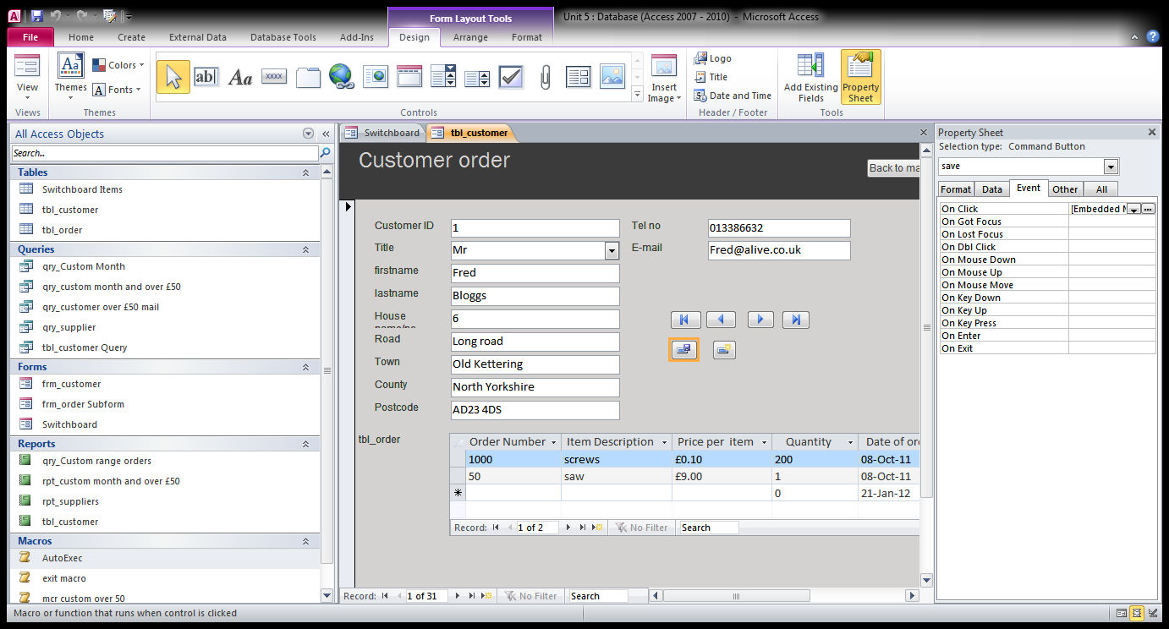

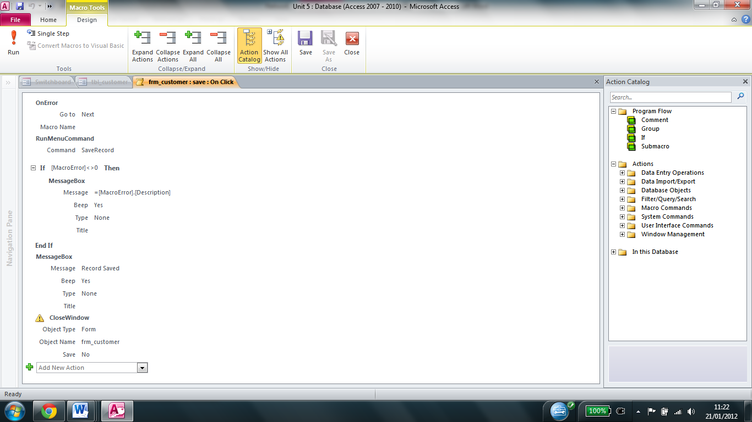

I then created the macro shown in design view to the left

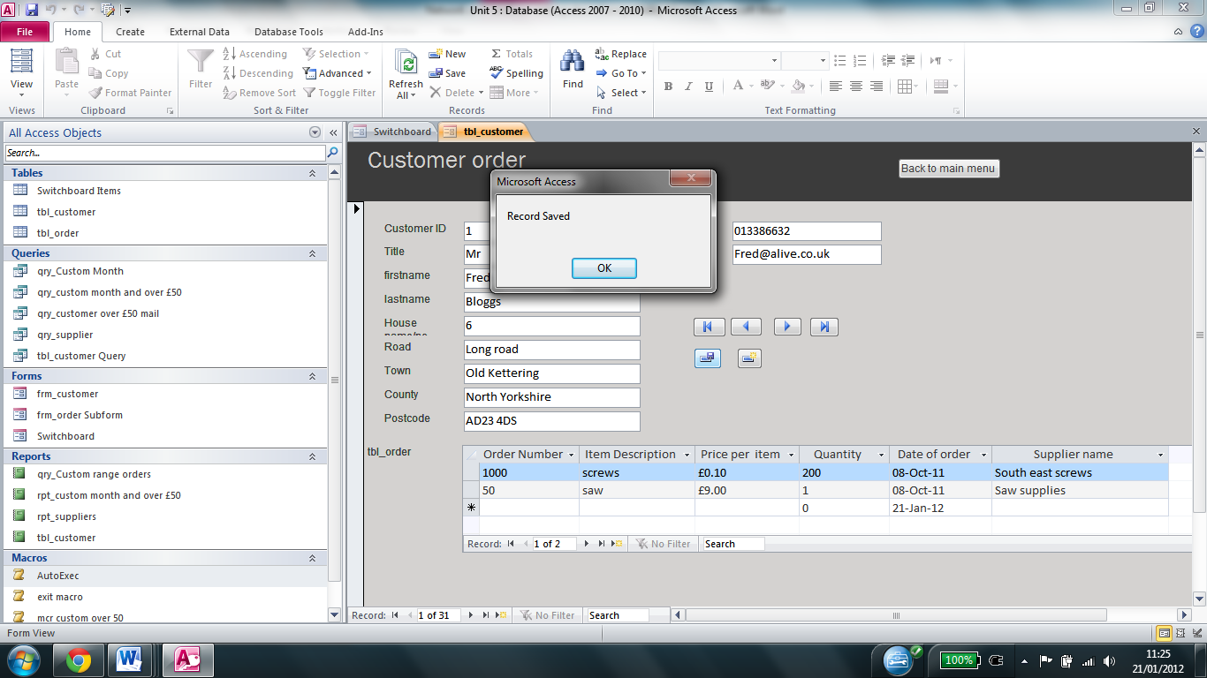When the save button is clicked, a confirmation is displayed on screen to tell the user that the record has been saved. It then closes the form.

**Mail merge**

I then created a mail merge letter to inform customers about the status of their order. To do so, I first had to create a query which contained all of the fields from both the of the tables, because otherwise you can only have fields from one table, and the data I needed for the letters was in multiple tables. A screen print of a section of this table can be seen below.

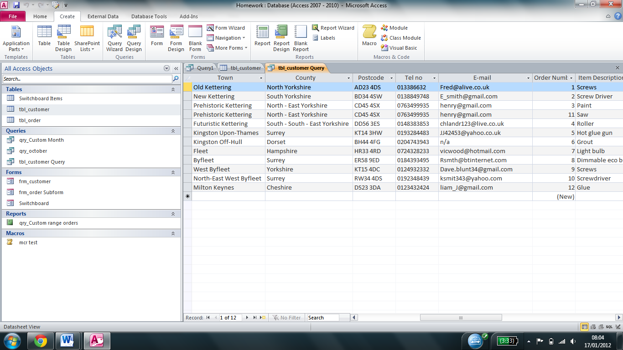

I then started the mail merge wizard in word to create the letter seen in appendix B. I first specified the location of the database and the query I had created. I then inserted fields from the database into the document as necessary, and wrote the letter. A screen print showing the mail merge fields can be seen below. The mail merge the fields are the ones with the «» either side of the field name

08

**Fall**

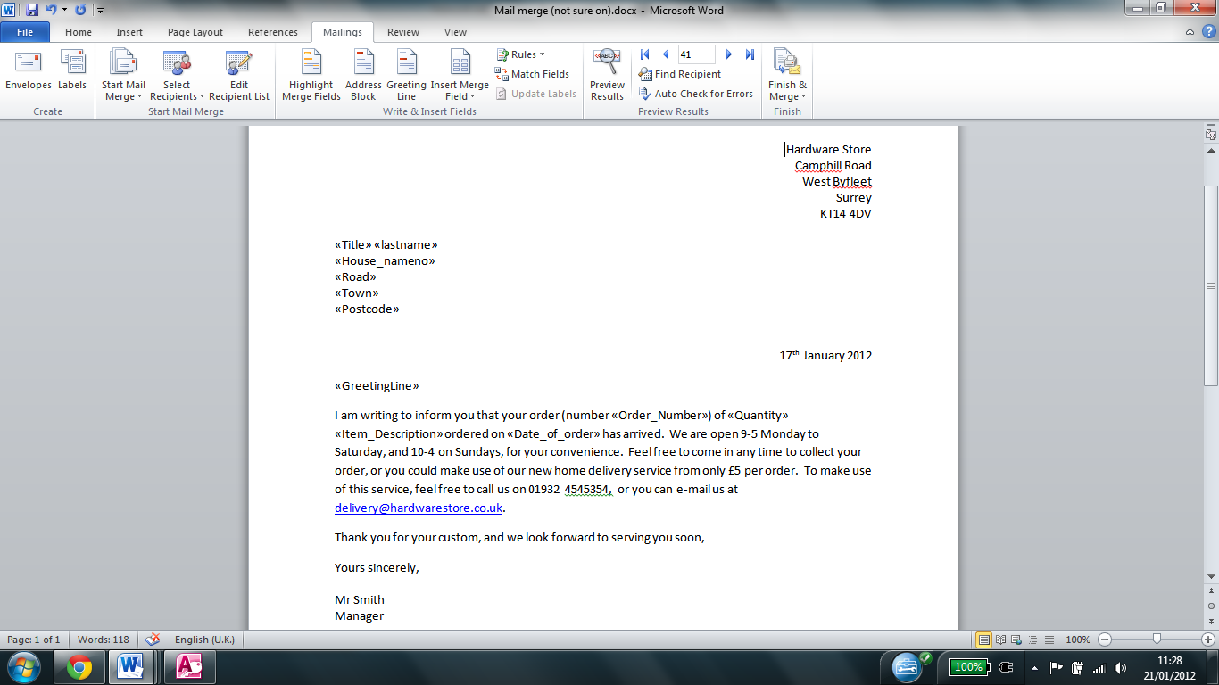

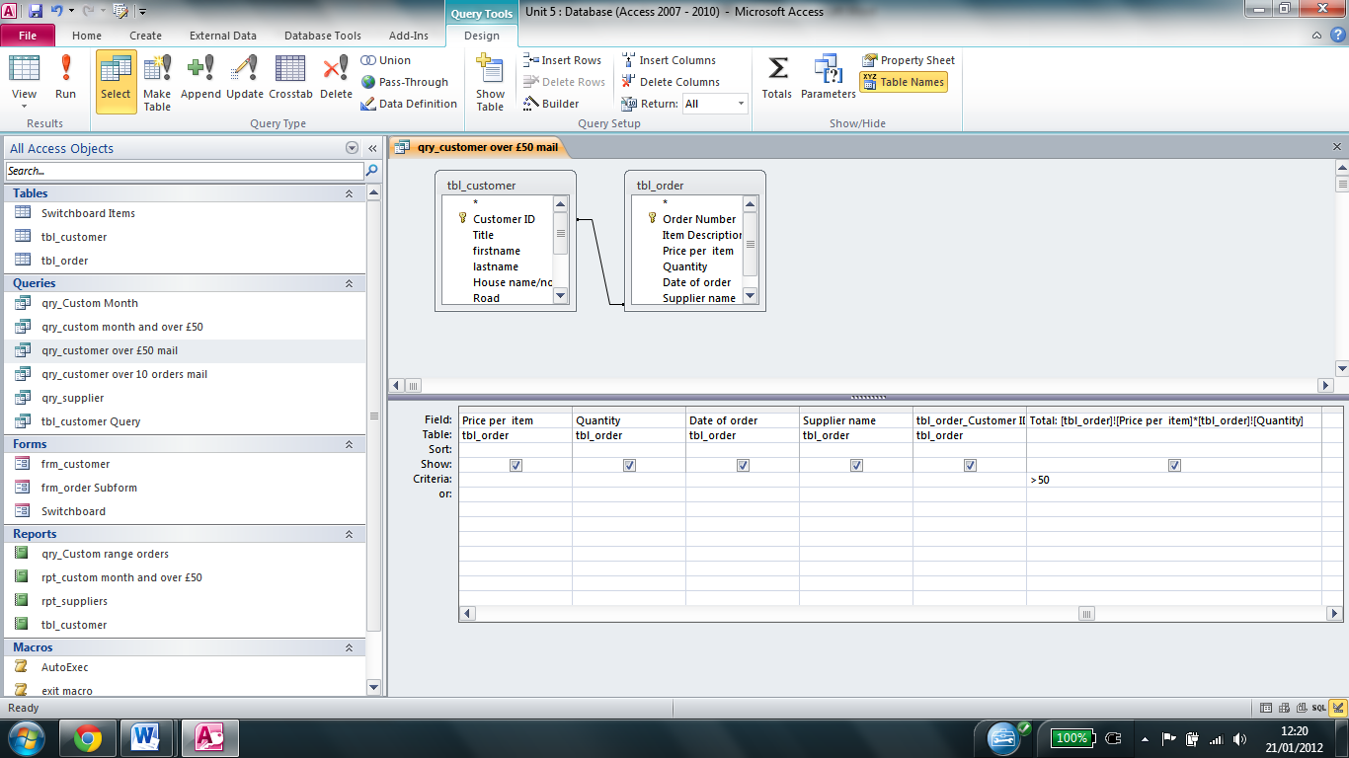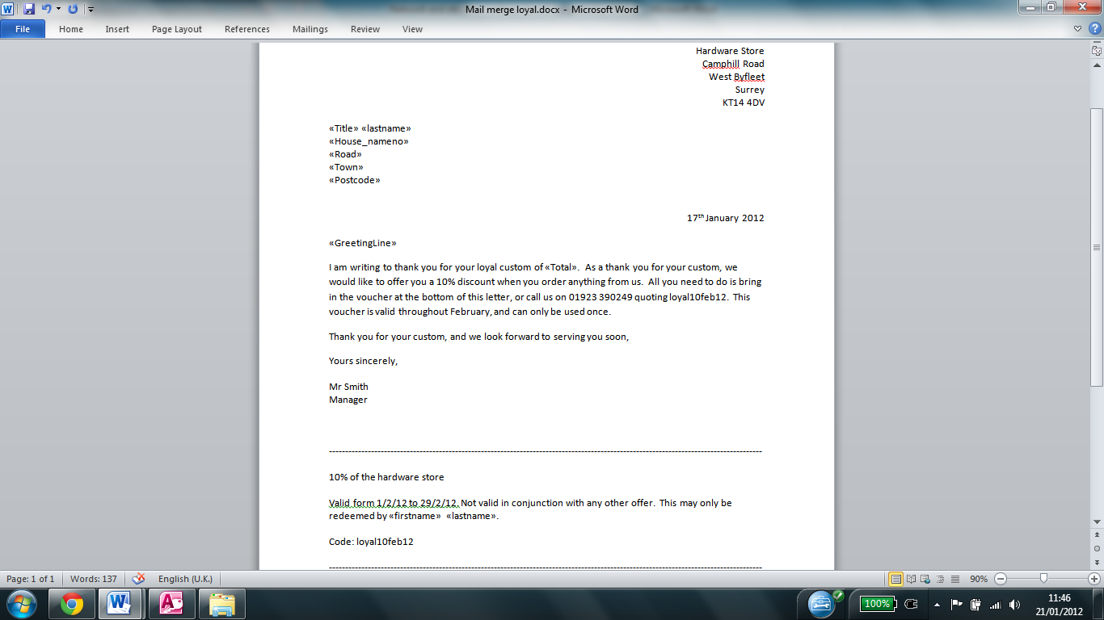I then created another mail merge letter to reward loyal customers who had spent more than £50 with a voucher for 10% off. I first created a query similar to the one used earlier, and I specified that the customer had to have spent over £50 as seen below on the right. The letter can be seen in appendix C, and the fields can be seen on the left

I also created a mail merge letter to reward customers who have ordered more than 10 items with 10% off. To do this, I first created a query for orders with more than 10 items.

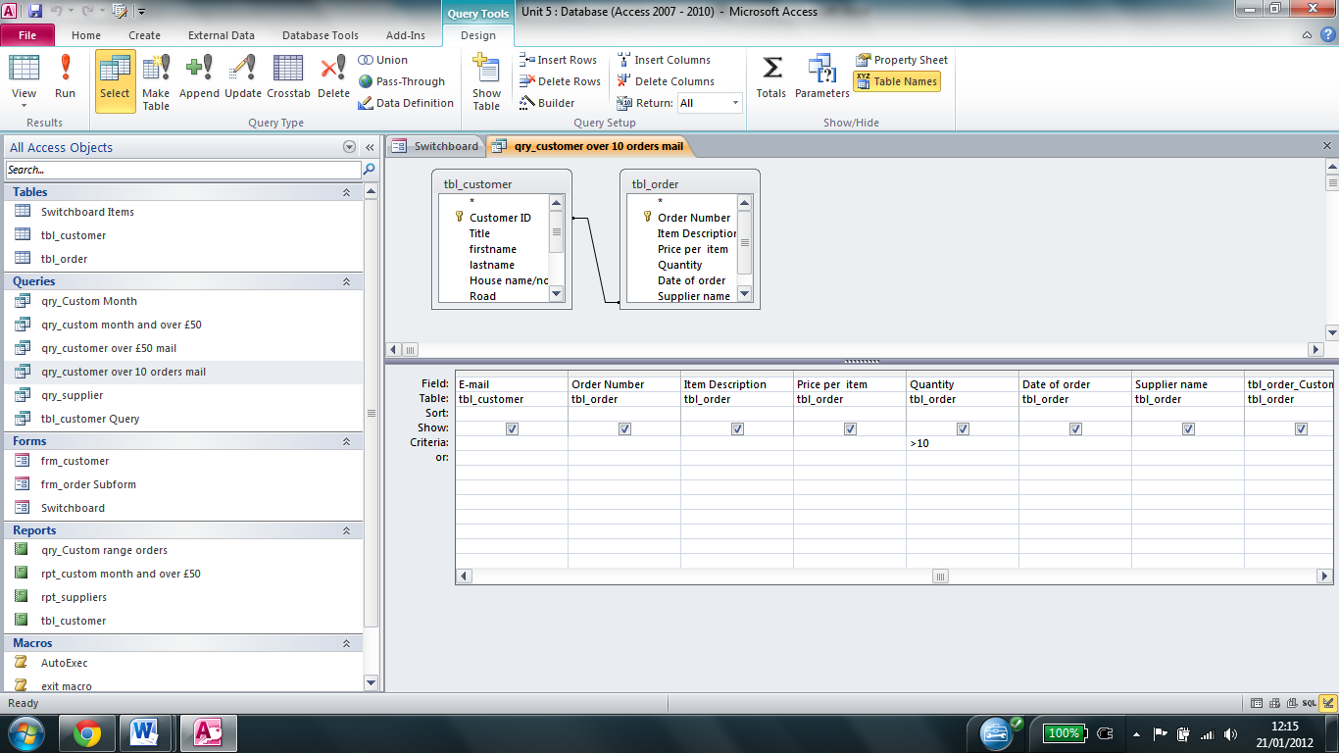

The mail merge letter can be seen in appendix D, and the mail merge fields can be seen below

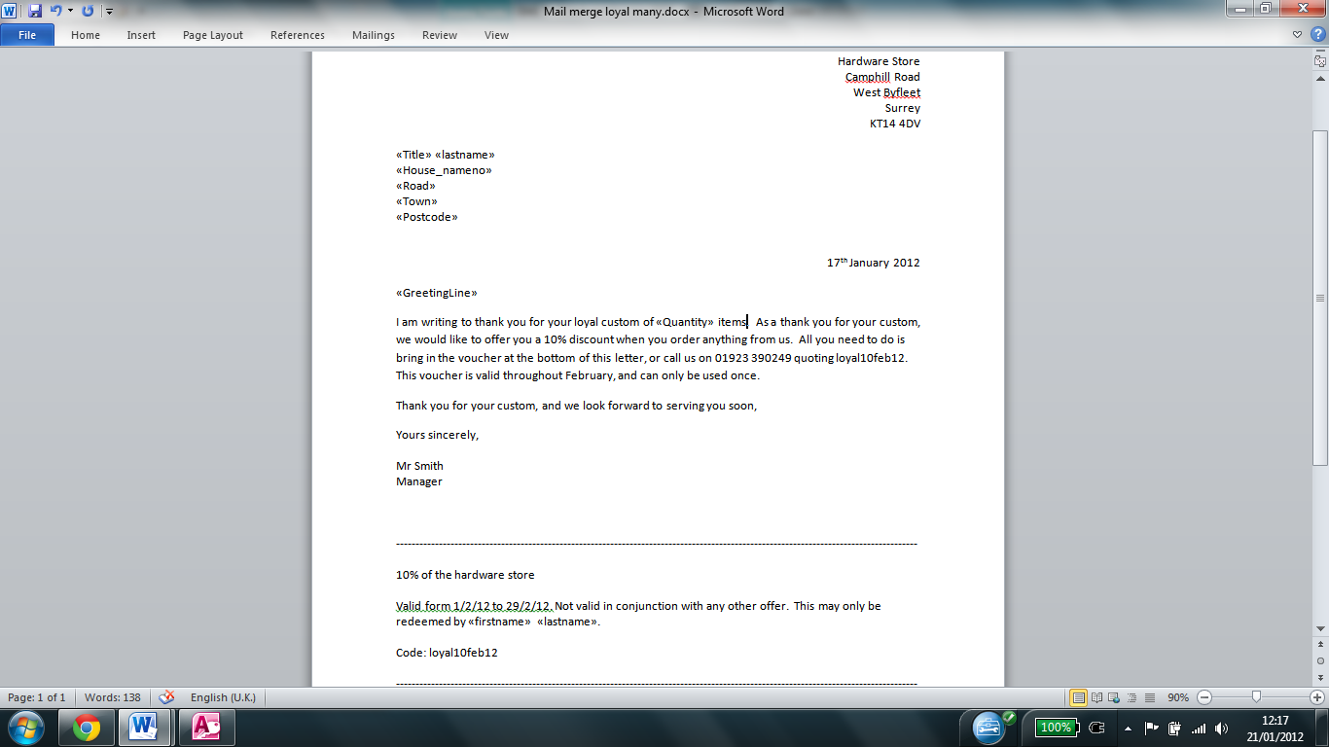

I also created a mail merge letter to inform customers who had ordered more than 10 items about a new paint service, using the same query as used above. The letter can be seen in appendix E, and the fields can be seen below.

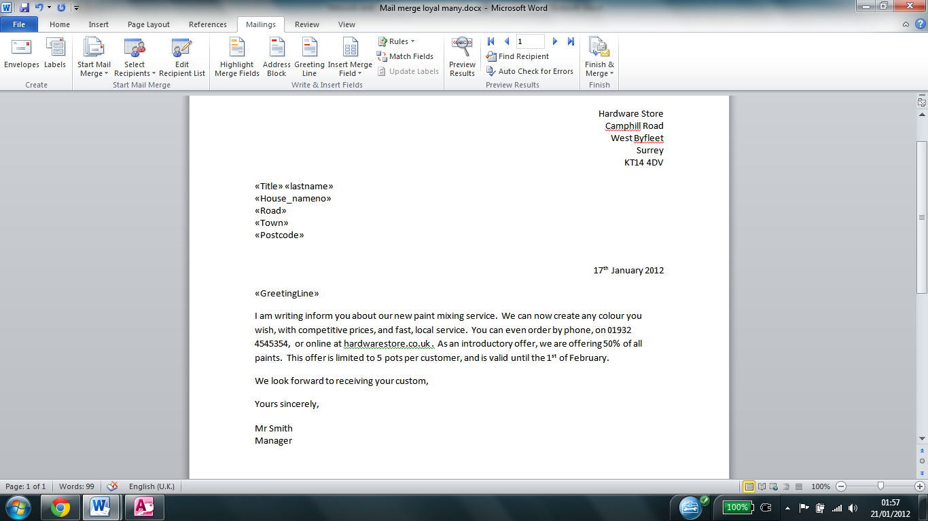

**Review:**

The criteria success criteria I agreed with Mr Smith was to have a database to provide the following services

1. Easy method of adding new customers and purchase information
2. Being to print a monthly sales report
3. Print a monthly report showing customers who have spent over £50 each month
4. Have an efficient method to search for customers
   1. Who have spent over £50 each month – mail merge list for Xmas card/voucher
   2. Who have bought 10 products – inform them of new product
   3. Orders over 10 – offer discount
5. Have an efficient method to search for supplier details and request new stock
6. Efficient method to update an existing customer information

A user can easily add new customer’s details and purchase info using the data entry form, and easily view the existing records, fulfilling the first criteria.

A monthly sales report can be generated from the option on the switchboard, which runs a macro to print out the sales report, fulfilling the second criteria.

A monthly report showing customers who have spent over £50 can be generated form the switchboard and the macro which is run will automatically printing it, making it easier to use.

I have created mail merge letters for the three criteria described under 4, allowing the hardware store to easily contact loyal customers. The user can also run the queries from the sidebar if they want to see the data outside of the letters.

I also created an efficient method to search for supplier details using the report which can be accessed from the switchboard

There is also an efficient method to update existing customer information by using the form, which can be accessed from the switchboard.

I also created a macro to automatically open the switchboard, so that users do not have to worry about which item to open.

For those reasons, I feel that the database is successful and fit for purpose. It is also easier to use than paper.

I feel that the database could have been improved by creating a macro to automatically print the supplier report since it would make it easier for the user, and would save time.

I got some users to test the database and this is some of the feedback I receved

“I found it easy to add details of new customers and that they have bought. I was able to make and save changes too.

Another user said “I would like instructions as to what format to enter date ranges in when requesting reports, but other than that, printing reports was easy – I was able to print monthly sales reports and reports for all orders over £50”

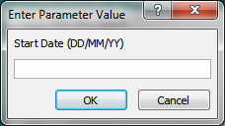In response to this feedback, I changed the message box text so it now tells the user the format in which to enter the date

Another user said “The mail merge letters for loyalty discounts and the adverts are really helpful. It automatically identifies customers spending over £50 or buying 10 items, although it would be better if the house number and road appear on one line.”

In response to that I made the house number and road on one line as seen below.

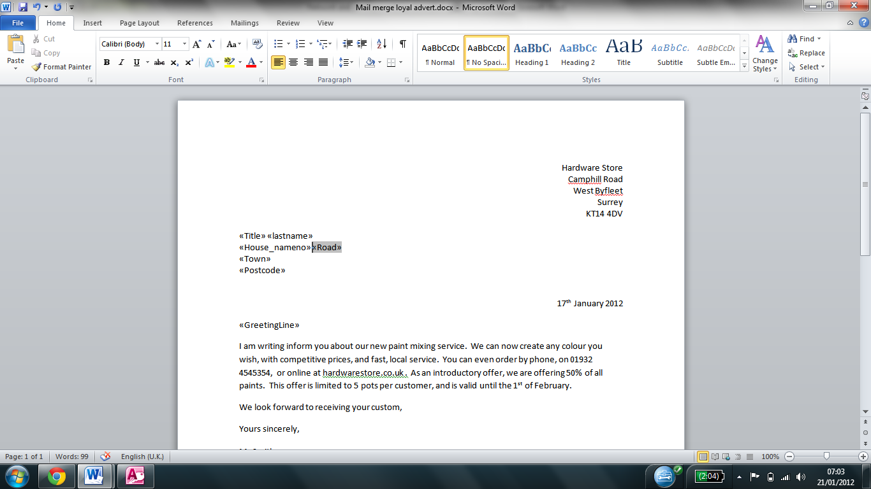

Another user said “On the data entry form it could be clearer that you can enter a house name or no.”

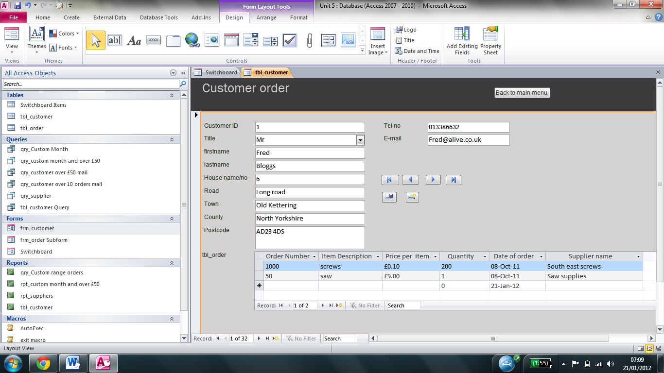In response to that, I resized the field to make it clearer

Following this feedback, and the changes that I have made, I feel that the database is fit for purpose and can be used in a hardware store to manage orders successfully.

|  |
| --- |
|  |
| Network write up |
| Andrew Burton 11DP |
|  |
|  |
|  |

**Network writeup**

The purpose of the network we created was to provide a network environment to support testing of robots in the school. The School network manager is the customer for this task. The software for the robots will be installed on the server, and the client PC’s will access programme from the server. The reason for this is because it means that we only need a licence for the number of users using the software at one time, rather than one licence per computer, making it more cost effective.

The success criteria that was agreed was:

1. To use the correct equipment for the task
2. Have a working network for school
3. To setup a secure environment to allow pupils to access the robot software
4. To setup appropriate drive mappings and security
5. To provide a backup/business continuity solution for the network

We were asked to have 3 client PC’s and 1 server on the network, since a maximum of 3 people at a time would be testing the robots. We connected the clients via Ethernet (RJ-45) cables to a 100Mbps switch and connect the server to the switch using Ethernet as well.

For our network, we decided to use windows server 2008 r2 for the server and windows 7 professional for the clients. The reason that we chose this combination is because it is the most commonly used setup in the industry for the sort of setup we were using, although there are other solutions on the market, including Linux which is widely used for web servers. We decided to run the server on citrix server, which allowed us to run multiple servers from one device, reducing costs and making the server more efficient. It also allowed us to access the server from anywhere, using the client program.

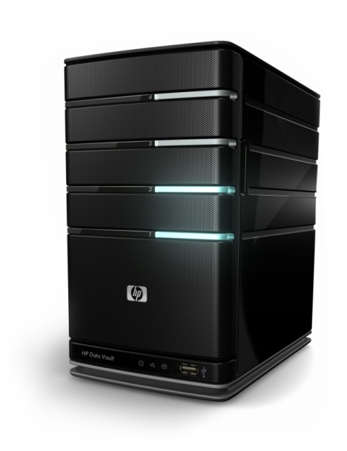

Server – 11.168.111.1

Intel XEON CPU

1x 500GB hard drive for files

1x 50GB hard drive for operating system

8GB ram

2 RJ-45 ports

Windows server 2008 r2

Cat 5E Ethernet cable

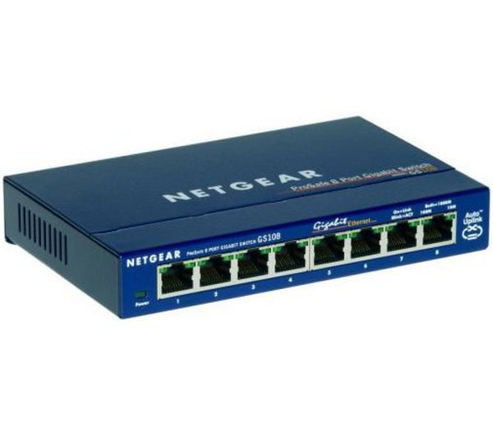

100Mbps switch

Cat 5E Ethernet cable

Client workstations (x3)

IP 11.168.111.2 – 11.168.111.4

Intel core 2 duo

Windows 7 pro

4GB ram

Intel GMA graphics

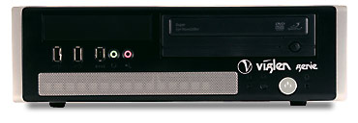

**Network components**

The server provided the IP addresses, DHCP services, and allowed the clients to easily share files between each other. It could have also have been configured to allow multiple users to log into any of the 3 workstations and have their files and settings be carried across. It is suites for the task because it is powerful enough to provide multiple services, such as DHCP, DNS and AD, without costing a lot of money. It can also be configured to have multiple hard drives, either in a RAID format, or as additional hard drives, which will provide better performance than external hard drive, and will mean that there is less chance of someone stealing a drive, since the hard drives can be locked into the server. It is also suitable since it runs windows server, which provides easy integration with the rest of the computers which run windows, making it easy to set up and troubleshoot.

The workstations allowed the users to carry out the testing on the robots, and allowed them to access files from the server. They are suitable for the task because they are not too powerful, since they do not need to be. They run windows 7, which will provide a realistic testing environment, since the rest of the school computers run windows 7, and most of the students would not know how to use other operating systems such as Ubuntu.

The switch allowed the computers to communicate with each other, and to communicate with the server. We used a 16 port netgear 100MB switch, since we would only have 4 devices connected to the network, however a 16 port switch would allow us to expand our network in the future should we decide we want to add additional devices to it, such as a printer. The reason that we chose a 100MB switch is because we did not need anything faster for what we were doing.

The cables connected the computers to the switch and the switch to the server. The server allowed us to attach 2 cables to it and the switch so if one of the Ethernet ports on the server broke, the server would still be able to function. The reason that we used cat 5E cables is because the switch we were using was only 100MB, but the cables would allow us to replace the switch with a 1GB switch and use the extra speed with no problem

We could have also attached a printer via Ethernet to the switch to allow the client pcs to print to the printer, and if we had multiple printers we could have set the server to specify which users can print to which printers and keep track of how much printing each user and each department is doing. Most printers have a print server built in, so all we would need to do is assign it a static IP address on the server, and add it to the clients, so no printing role would need installing on the server, making it easier to troubleshoot, since a user with non admin rights can restart the printer. However we didn’t because we were not required to.

Had we connected our network to the internet, we would have needed an Internet Service Provider (ISP) to provide us with our internet connection. We would have also needed a firewall to stop unauthorised users from attacking the network. We would have also needed a modem to connect to the internet using the ISP.

**Business continuity**

Business continuity is the term used to describe processes used to ensure that critical business systems are always available. If Business continuity is not implemented, it could have catastrophic results for the business. According to the National Archives and Records Administration, 93% of companies whose datacentres were down for more than 10 days or more went bankrupt. Therefore it is vital that a business implements business continuity to ensure that their critical systems remain online. Listed below are a few ways an organisation may implement business continuity.

**Methods used for Business Continuity**

I have researched the following:

1. Backups via tape or external hard drive are used to ensure that the files and data as well as operating systems for the servers are always available, meaning that even if a critical file is deleted, the file is stored somewhere. A business may also choose to have backups kept off site so if the main server building is damaged, the files are still accessible.
2. A business may also choose to have redundant hardware (hardware which is in another location to the main hardware in case anything happens to the main hardware) mirroring the main hardware (ie if someone saved a document on their network drive on the main hardware, it would also be saved on the redundant hardware), so if something happens to the main hardware then the files are still safe, and operations can continue as if nothing has happened, allowing the business to be more efficient. If a business did not have this, it could stop them from functioning altogether. For example, if an e-commerce website is offline, then it would stop them receiving any new business. Therefore it is essential for businesses to have redundant hardware.
3. A business will also have rights or mapped drives so that staff do not have access to sensitive information which they do not need access to. In our situation, rights may be implemented to stop a student accidently deleting a critical operating system file, or spreading a virus thought the entire network
4. They may also have a policy to ensure that staff saves files to their network drive which is regularly backed up as opposed to the local hard drive or USB which would not be backed up. Some businesses may even block access to USB drives to prevent sensitive information from leaving the organisation.
5. An organisation may also have a RAID solution set up on their servers. This would mean that when a file is modified it is saved onto all of the disks in the RAID system. If a disk was to fail, it could then be easily swapped out for another drive, and the files would automatically be copied to the new drive with no loss to productivity. However, a business would not use this as their only backup solution since if all of the drives were in the same building, and something happened to the building then all of the work could be lost.
6. An organisation would also have antivirus on their servers and client PC’s to stop unauthorised users obtaining access to confidential information, since if this information is obtained, it could result in the company losing customers and having to compensate their customers. If an organisation did not have antivirus, it could also result in loss of files, amongst other things. It is important that the antivirus and operating system are kept up to date so that new viruses are blocked, since new viruses are developed almost every hour.

With our network we are aiming to provide a business continuity solution for an application being installed in a school environment, which primarily focuses on pupils not having access to the servers, software and data.

I would recommend using the solutions:

1. Backup
2. Raid
3. Anti-virus
4. Access rights

The reason for having backup is because if the server or one of the clients fail, then it can be quickly replaced, or if a critical file is deleted, then the file can be replaced. If the file which has been damaged is a critical operating system, then the server can be restored from the

We first installed windows server 2008 r2, choosing the standard 64 bit version from the list as seen below

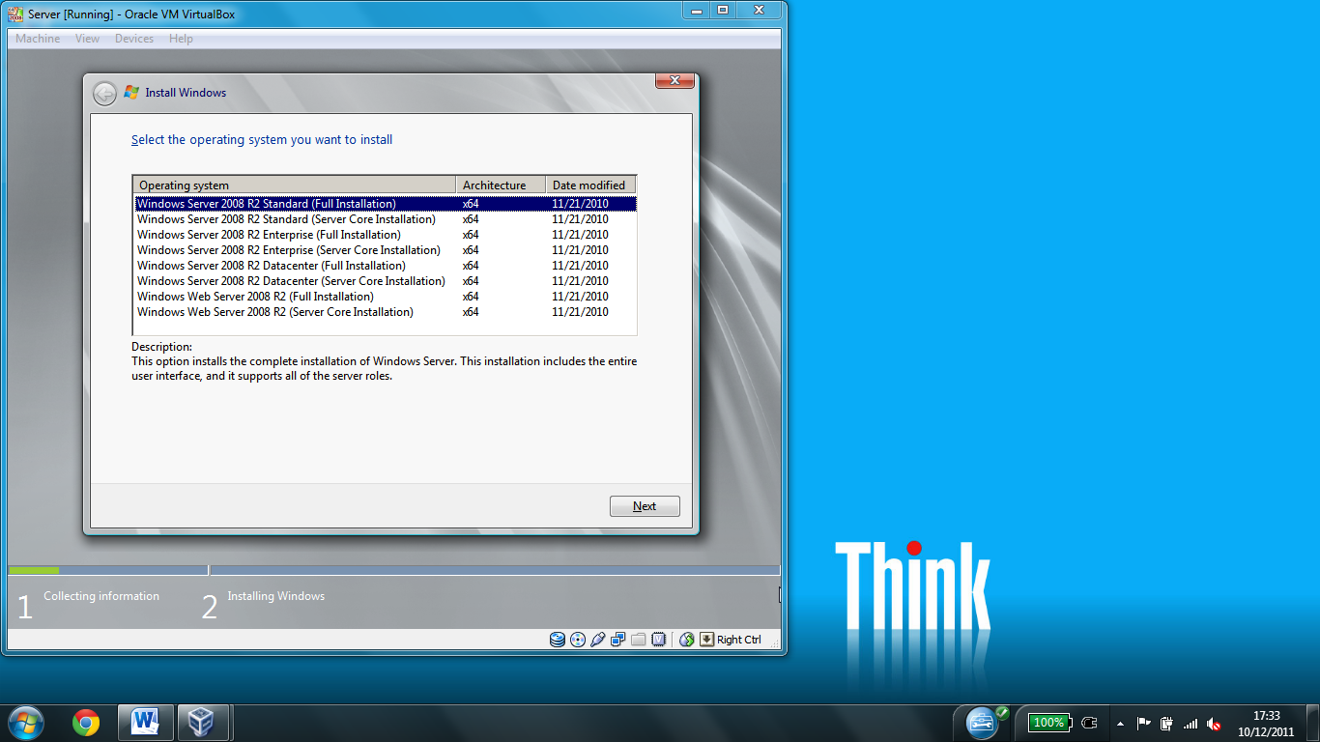

We then proceeded to install windows server, overwriting any partitions since we were doing a clean install of windows server, and accepting the licence agreement which stated what we were and were not allowed to do with the software in the process.

Once we read and accepted the licence agreement, windows server installed.

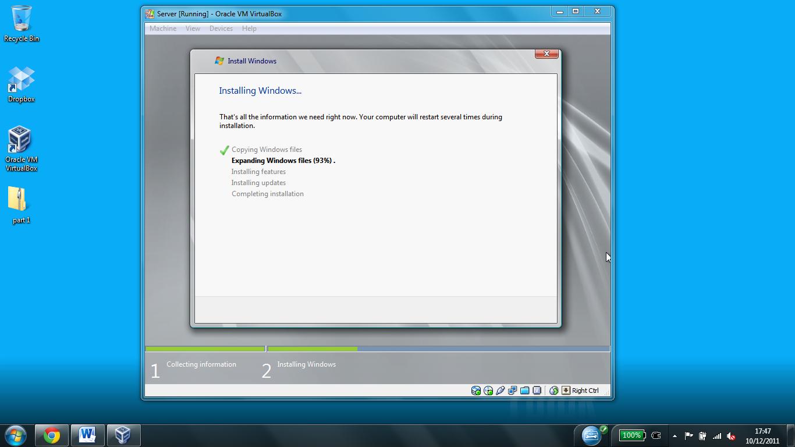

Once windows server had installed we were greeted by this screen

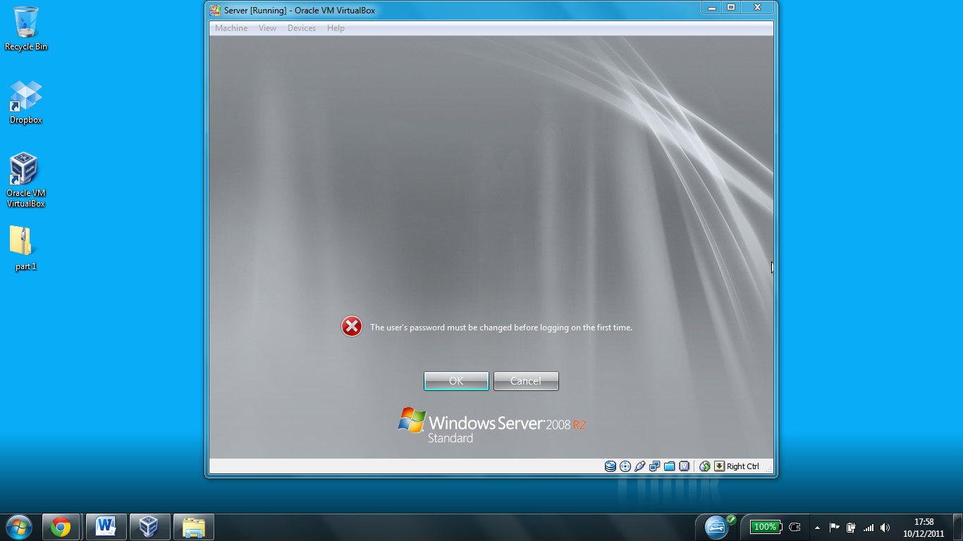

The reason for this is because there was no password assigned by default, and in order to meet windows server 2008’s default security policy, the password had to be changed to a strong password. The reason for this is because due to the large amount of data that is stored on the server, and the large amount of services a single server provides makes them a greater hacking threat, and having a strong password reduces the risk of someone guessing the password and accessing the data and services.

We first assigned a manual IP address to the server. If it didn’t have one assigned then the clients would have nowhere to obtain IP addresses from, and the server wouldn’t be able to communicate with the other devices on the network.

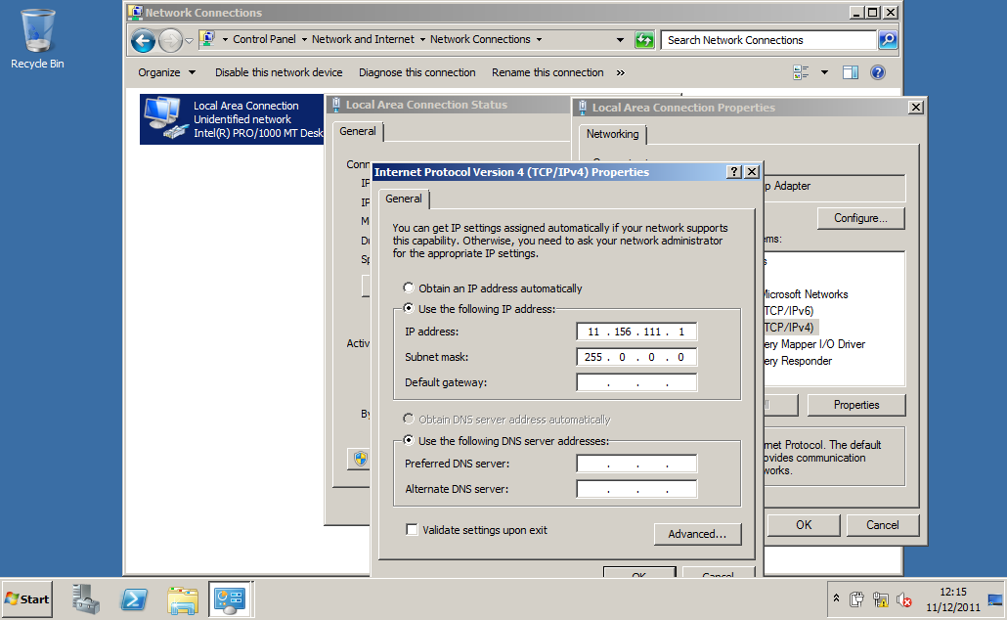

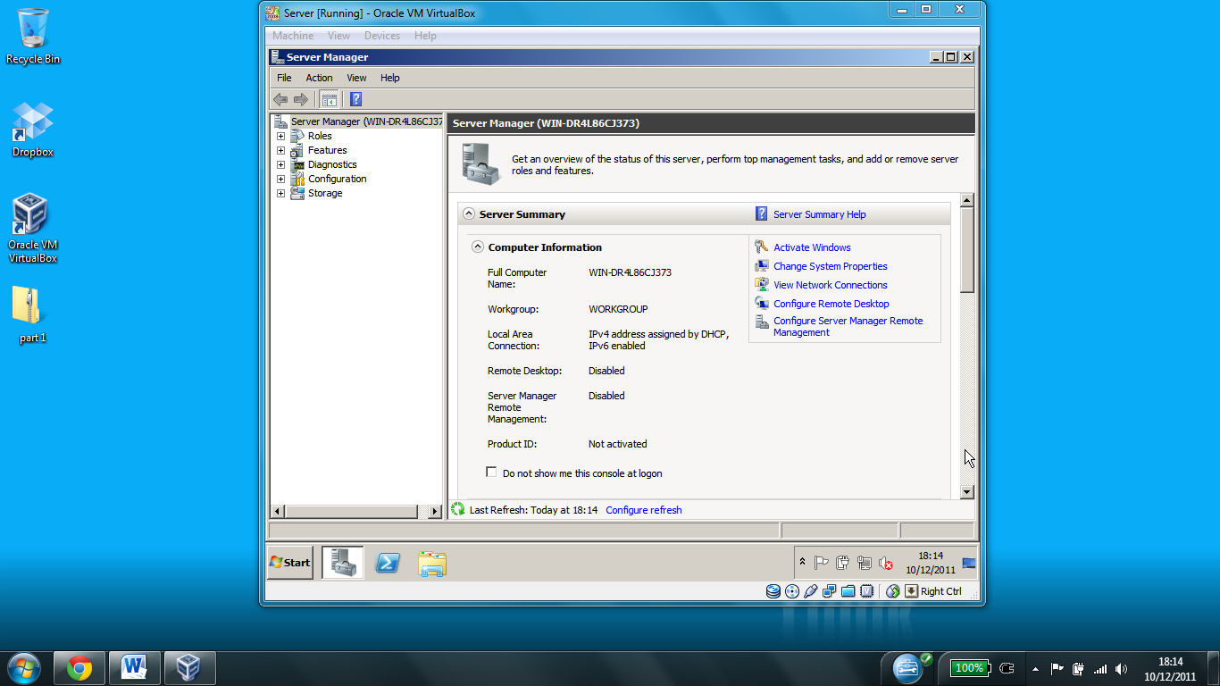We then launched the server manager and were presented with the screen shown below. This shows the status of the server, such as the status of the roles (such as DNS) and the activation status

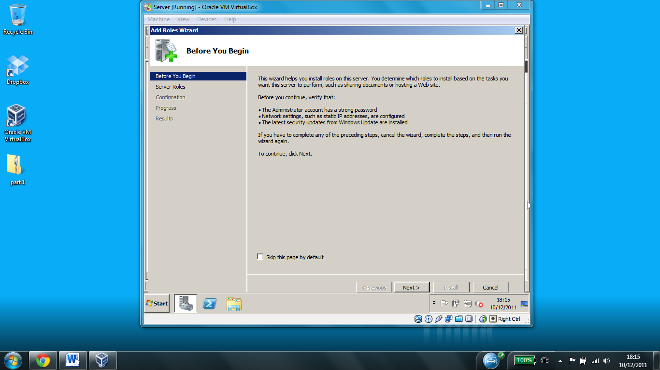We then launched the add roles wizard by clicking on roles and then add roles. The roles provide services, such as DNS

On clicking next we were chose to install the DNS and DHCP server roles

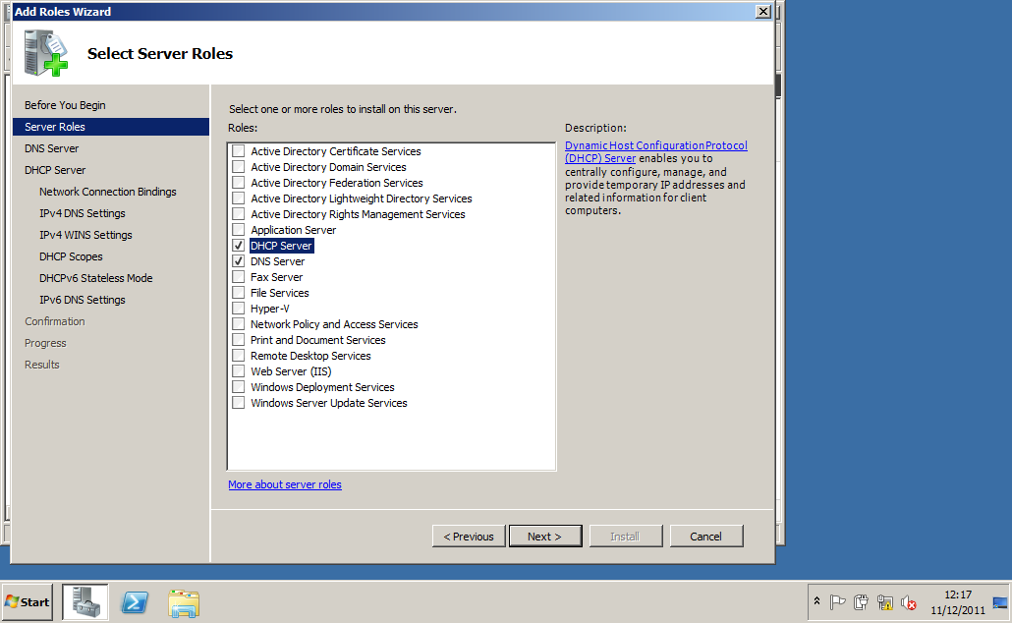

The DHCP role allows the server to assign an IP address to the clients. It can either be configured to assign the same IP each time a client connects (static ip), or assign a free IP (Dynamic IP). Dynamic IPs are mainly used for workstations, since a new one can be easily added, and static IPs are used for printers and servers because the workstations will have been given that IP. The DNS role turns the IP address into something more user friendly (e.g. Printer instead of 192.168.0.8). This is particularly useful in larger networks where there may be hundreds of devices on a network; since the name can be in a format where it can say where the printer is (e.g.a printer may be named PRN-IT-1 to show that it is a printer in the IT department)

We then rebooted the server and installed Active directory domain services, which allowed us to join a client PC onto the server.

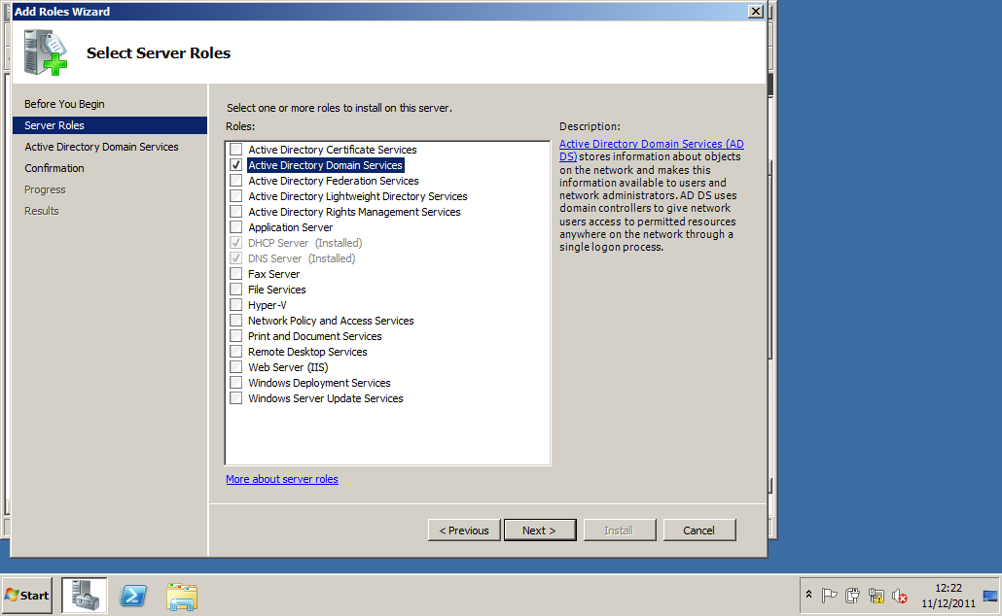

We then rebooted the server again and ran the active directory domain services installer, creating a new domain in a new forest, and specifying folders for the database and the log files in the process

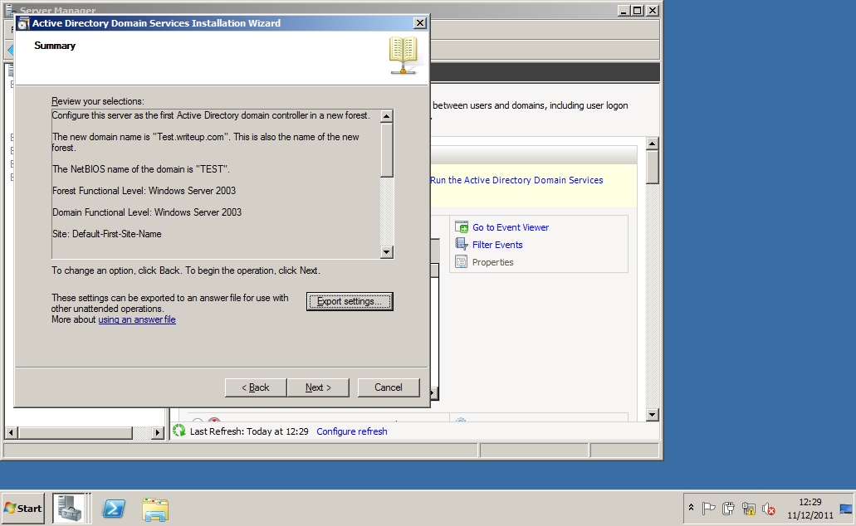

We then went into the DHCP server settings and created a scope for distributing the IP addresses to the network. The scope identifies the range of ip addresses which can be assigned. In this case it is 11.156.111.2 to 11.156.111.200

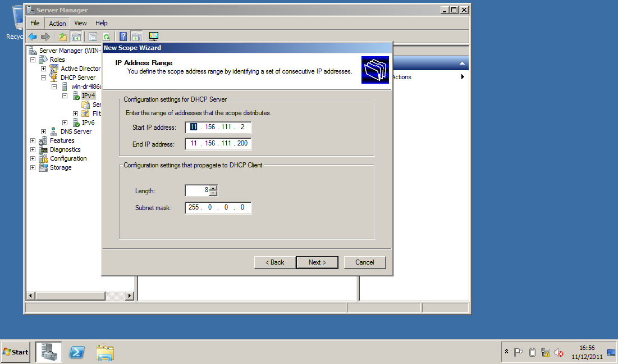

We then joined the client pc to the network by automatically assigning it an IP address as seen below

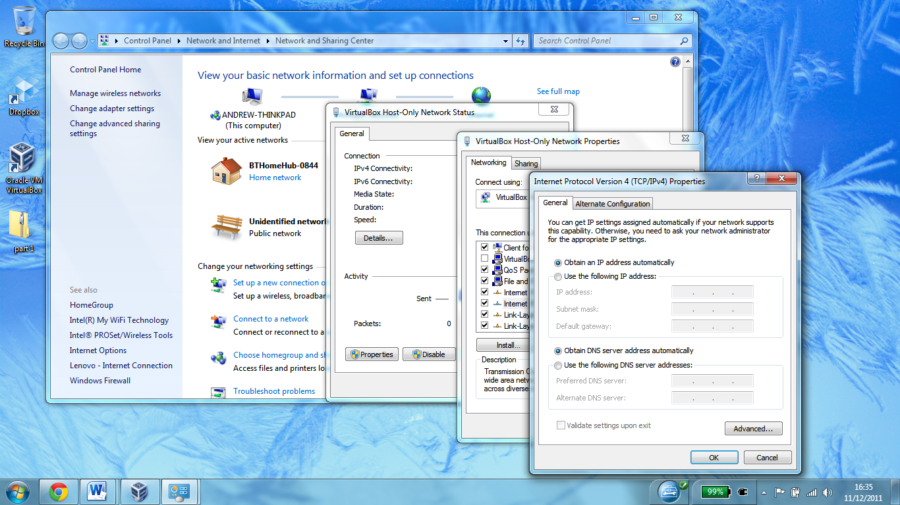

Once we had done that we used the command line to ping the client and the server. Here we can see client pinging the server successfully

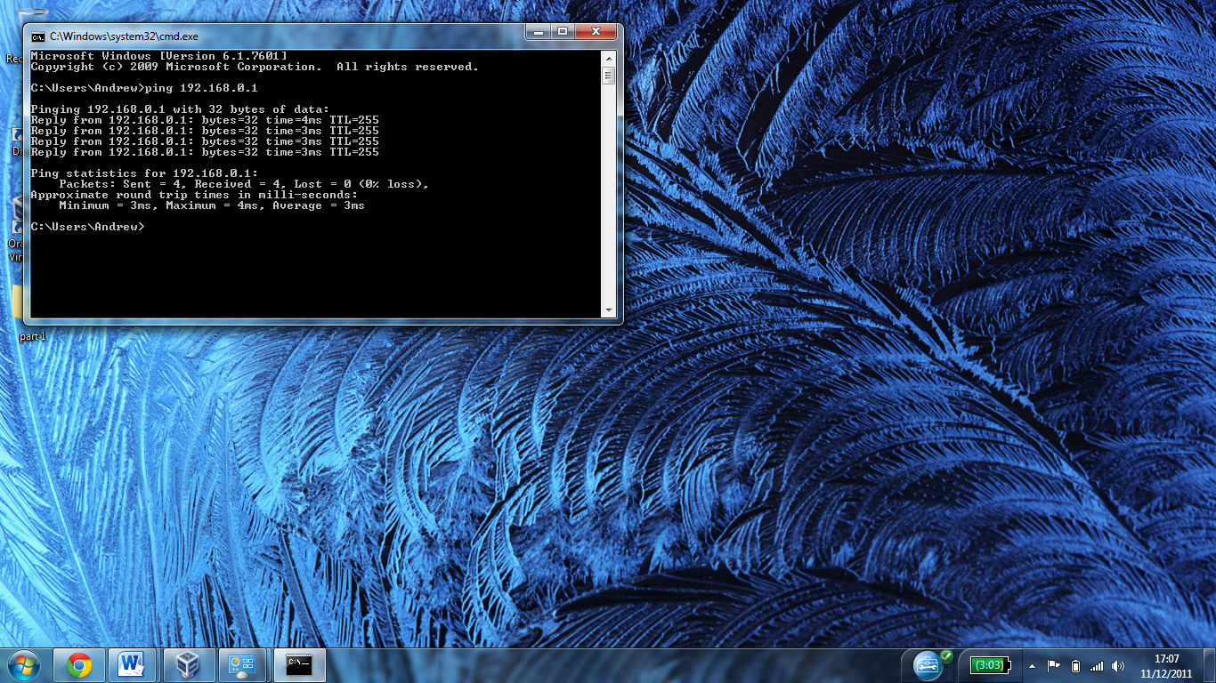

Once we had done that we added the client PC to the domain

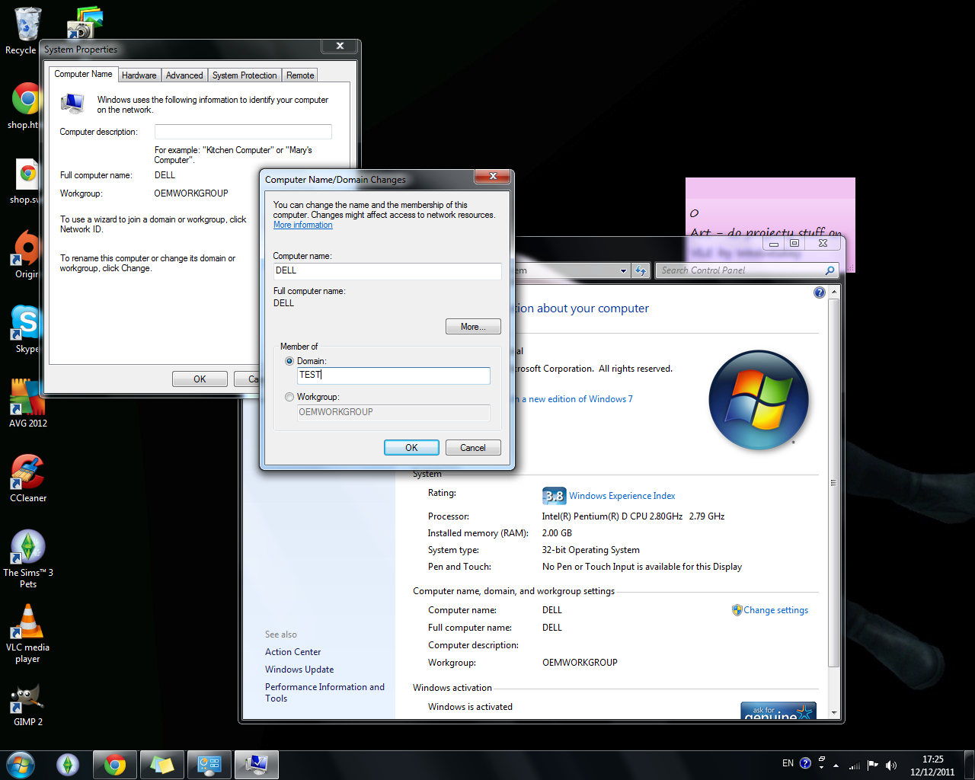

**Testing**

To test our network we used a number of things. The reason that it is important to test the network is to ensure that the network is functional and all data is secure, and to help identify any issues as soon as they occur

To test logging on we set up an active directory account on the server and logged on using the account and checked that a network drive was displayed. We also tried logging on with an incorrect password to ensure that a correct password had been assigned.

After logging on we used IPCONFIG to test that a correct IP address within the designated scope had been correctly assigned to the client. We also pinged another device on the network. This tested that the workstation being tested had a valid IP, that the network speed was sufficient, and that the workstation was responding and communicating with other devices on the same or a different network. It also allows identifying the DNS name assigned to an IP address and vice versa.

An example of a ping test can be seen below.

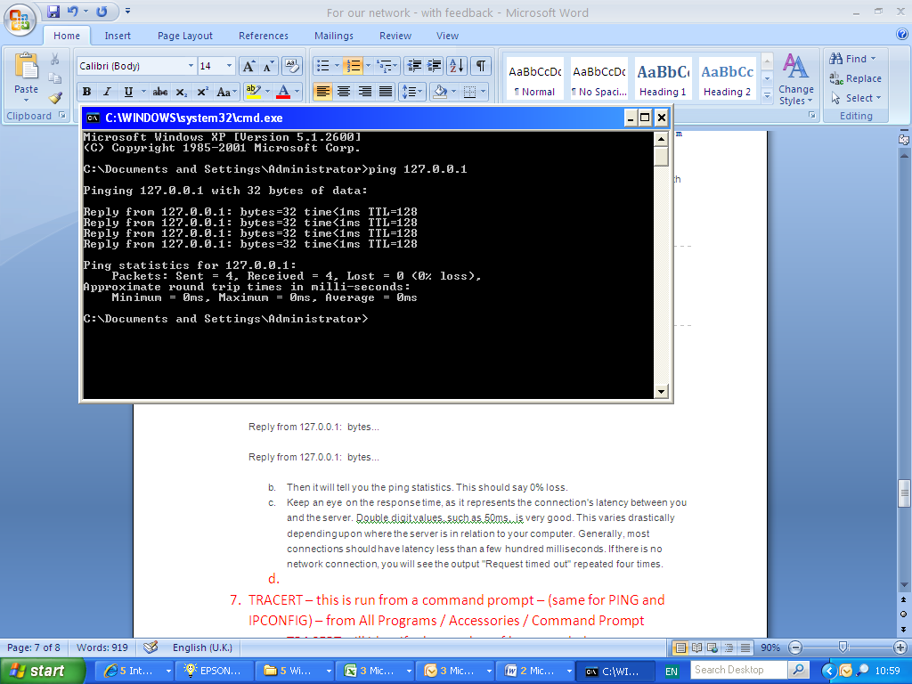We also created a backup of a server to en external drive using the built in windows backup service, and restored it to ensure that the backup system was functioning correctly. We could have also set up a mirrored raid system, which is effectively multiple hard drives which mirror each other. If one drive fails, then the contents would be safe on another drive. A business should regularly test the backups to ensure that the backup system is working correctly.

To ensure that everything was functioning, we also checked in the event viewer and the server manager to make sure that everything is reported to be correctly functioning. The event viewer shows all of the events that have occurred, including errors which makes it easier to diagnose problems.

**Troubleshooting**

If a user was unable to log on, then I would first reset the users password, and then get them to try it. If they could still not log on then I would try to log on using the same username and password to another computer. If that worked, then I would ping the machine’s IP address to see if it is on the network. If the ping returned no results, then I would perform a visual check on the machine (check cables, make sure that the status lights are normal etc). I would then try plugging the Ethernet cable into another PC to see if it is a problem with the network or the PC. If the cable worked with another PC then I would see if windows is correctly identifying the hardware, and that all of the drivers were installed. If the drivers were installed but windows was not recognising the hardware, then I would swap the network card if the computer was a desktop, or swap the machine if the computer was a laptop, since most laptops have the network card soldiered to the motherboard.

**Review**

The success criteria that was agreed was:

1. To use the correct equipment for the task
2. Have a working network for school
3. To setup a secure environment to allow pupils to access the robot software
4. To setup appropriate drive mappings and security
5. To provide a backup/business continuity solution for the network

I feel that we did use the correct equipment for the task, and that it was fit for the purpose. I feel that we could have used cat 6 cables and a 1GBps switch, however the equipment we used would be ok for a test network

The network would be suitable for a school environment because the data is backed up away from the server, and access rights can be implemented to stop

Review the progress against the success criteria described below:

Success criteria:

1. Used the correct equipment for the task
2. Working network for school
3. Setup a secure environment to allow pupils to access the robot software
4. Setup appropriate drive mappings and security
5. To provide a backup/business continuity solution for the network
6. Used the correct equipment for the task: describe if your thought the equipment was appropriate (Fit for purpose) ...discuss
7. Working network for school: ... discuss.. pros/cons
8. ...